**The Effects of Simplifying First-Person Shooter Controls**



**Project**

**Christopher Ross**

**ROS16626280**

**BSc (Hons) Games Computing**

**Supervisor: Paul Baxter**

# Abstract

With the ever-increasing numbers of new players in coming to PC and playing first-person shooters, it is becoming more and more important to discover a way of balancing the odds between players who have played this genre on PC for years and those who have not.

This projects research is based around creating a control scheme that allows new players an easier way of grasping game mechanics and increasing their overall player experience and immersion within first-person shooters. To do this, two identical games were created with differing control schemes where one used a layout typically found on any normal first-person shooter and the other used a more simplified, understandable and partially automated set of controls.

The game itself went through three major iterations of testing all of which were completed through player questionnaires and observations. The first two iterations were to discover the how enjoyable the game was to play and after two attempts it was finally deemed suitable. The final iteration of testing was done to test the newly designed control scheme.

The results were overall positive, suggesting that players with more experience preferred the non-simplified version whereas those who did not have any prior experience preferred the simplified version.

# Acknowledgments

* I would first like to say thank you to my fiancée Rachel, for all the love and support that you have given me throughout the years, and for always being there when I need you the most. You have always put up with me stressing out over the magnitude of work I always need to do, and somehow you have always convinced me to push on, do better and more than I ever thought I could. For this I am eternally thankful.
* I would also really like to thank Paul Baxter for his excellent guidance and supervision throughout this project. I have really enjoyed our chats, conversations and all the extra tips on how I can improve my project.
* I would also like to give a special thank you to Chris Headleand, and Mark Doughty for being amazing tutors, guiding me throughout the years at university. I have really appreciated the support, opportunities, feedback, and everything else that you have both given me.
* Finally, I would like to thank all of my friends and the people who played my game and gave such great feedback, it really motivated me throughout this project to push further.

# Table of Contents

[Abstract 2](#_Toc5395747)

[Acknowledgments 3](#_Toc5395748)

[Table of Contents 4](#_Toc5395749)

[Table of Figures 6](#_Toc5395750)

[1 Project Background 7](#_Toc5395751)

[1.1 Introduction 7](#_Toc5395752)

[1.2 General Motivation 8](#_Toc5395753)

[2 Aims and Objectives 9](#_Toc5395754)

[2.1 Aims 9](#_Toc5395755)

[2.2 Objectives 9](#_Toc5395756)

[2.2.1 Objective 1: Research 9](#_Toc5395757)

[2.2.2 Objective 2: Design & Implementation 9](#_Toc5395758)

[2.2.3 Objective 3: Evaluation and Conclusion 10](#_Toc5395759)

[3 Literature Review and Background Research 11](#_Toc5395760)

[3.1 Summary 11](#_Toc5395761)

[3.2 Player Immersion 12](#_Toc5395762)

[3.3 Game Design 13](#_Toc5395763)

[3.4 Balancing Challenge 15](#_Toc5395764)

[3.5 Control Scheme Evolution 16](#_Toc5395765)

[3.6 Fitt’s Law 18](#_Toc5395766)

[4 Methodology 19](#_Toc5395767)

[4.1 Project Management 19](#_Toc5395768)

[4.2 Project Plan 21](#_Toc5395769)

[4.3 Tools 24](#_Toc5395770)

[4.3.1 Development Tools 24](#_Toc5395771)

[4.3.2 Development Environment 27](#_Toc5395772)

[4.3.3 Evaluation Tools 27](#_Toc5395773)

[4.4 Testing 28](#_Toc5395774)

[4.4.1 Enjoyment Test 28](#_Toc5395775)

[4.4.2 Control Scheme Test 29](#_Toc5395776)

[4.5 Research Methods 30](#_Toc5395777)

[5 Design 31](#_Toc5395778)

[5.1 Lo-Fidelity Prototypes & Sketches 31](#_Toc5395779)

[5.1.1 Sketches 31](#_Toc5395780)

[5.1.2 Experience Flow Diagram 32](#_Toc5395781)

[5.1.3 Storyboarding 32](#_Toc5395782)

[5.1.4 One Page Design Document 33](#_Toc5395783)

[5.2 Game Design Document 34](#_Toc5395784)

[5.2.1 Mechanics, Dynamics and Aesthetics 34](#_Toc5395785)

[5.2.2 Game Features 35](#_Toc5395786)

[5.2.3 Game Controls 36](#_Toc5395787)

[5.3 The Final Product 38](#_Toc5395788)

[6 Evaluation 41](#_Toc5395789)

[6.1 Enjoyment Testing 41](#_Toc5395790)

[6.1.1 Test 1 41](#_Toc5395791)

[6.1.2 Test 2 42](#_Toc5395792)

[6.2 Control Scheme Testing 43](#_Toc5395793)

[6.2.1 Player Categorisation 43](#_Toc5395794)

[6.2.2 Results 43](#_Toc5395795)

[7 Conclusion 45](#_Toc5395796)

[8 Critical Reflection 46](#_Toc5395797)

[8.1 Description 46](#_Toc5395798)

[8.2 Feelings 46](#_Toc5395799)

[8.3 Evaluation 47](#_Toc5395800)

[8.4 Analysis 47](#_Toc5395801)

[8.5 Conclusion 47](#_Toc5395802)

[8.6 Action plan 48](#_Toc5395803)

[9 Appendices 49](#_Toc5395804)

[9.1 Item 1: Enjoyment Questionnaire v1 49](#_Toc5395805)

[9.2 Item 2: Enjoyment Questionnaire v2 52](#_Toc5395806)

[9.3 Item 3: Control Questionnaire 57](#_Toc5395807)

[9.4 Item 4: One-Page Design Document 60](#_Toc5395808)

[10 References 61](#_Toc5395809)

# Table of Figures

[Figure 1: Jones' model of the design process (Jones, 1992) 14](file:///C:\Users\mrchr\Documents\Github\Project\Project.docx#_Toc5395810)

[Figure 2: MDA framework (Hunicke et al., 2004) 14](#_Toc5395811)

[Figure 3: The Pareto Frontier 15](file:///C:\Users\mrchr\Documents\Github\Project\Project.docx#_Toc5395812)

[Figure 4: Wolfenstein Game Manual (id Software, 1992) 16](file:///C:\Users\mrchr\Documents\Github\Project\Project.docx#_Toc5395813)

[Figure 5: Fitt's Law - Shannon Formulation (Mackenzie, 1991) 18](#_Toc5395814)

[Figure 6: The Spiral Model (Boehm, 1986) 20](#_Toc5395815)

[Figure 7: Project Flowchart 22](#_Toc5395816)

[Figure 8: Gantt Chart 23](file:///C:\Users\mrchr\Documents\Github\Project\Project.docx#_Toc5395817)

[Figure 9: GitHub Desktop 24](#_Toc5395818)

[Figure 10: GitHub Commit 24](#_Toc5395819)

[Figure 11: The Unity User Manual 25](#_Toc5395820)

[Figure 12: Unity Questions 25](#_Toc5395821)

[Figure 13: Unity Game Engine 26](#_Toc5395822)

[Figure 14: Unity Build Settings 26](file:///C:\Users\mrchr\Documents\Github\Project\Project.docx#_Toc5395823)

[Figure 15: Likert Scale 28](#_Toc5395824)

[Figure 16: Insights 29](#_Toc5395825)

[Figure 17: Control Scheme Test - Section Three 29](#_Toc5395826)

[Figure 18: Research Methods (University of Newcastle, 2019) 30](#_Toc5395827)

[Figure 19: Sketch Ideas, Game Evolution, and Player Abilities 31](#_Toc5395828)

[Figure 20: Game Object, Feature, and Floor Plan Creation 31](#_Toc5395829)

[Figure 21: Experience Flow Diagram 32](#_Toc5395830)

[Figure 22: Storyboarding 32](#_Toc5395831)

[Figure 23: One Page Design Document 33](#_Toc5395832)

[Figure 24: MDA Framework 34](#_Toc5395833)

[Figure 25: The Player 35](file:///C:\Users\mrchr\Documents\Github\Project\Project.docx#_Toc5395834)

[Figure 26: The Cube 35](file:///C:\Users\mrchr\Documents\Github\Project\Project.docx#_Toc5395835)

[Figure 27: Type 2 Enemy 35](file:///C:\Users\mrchr\Documents\Github\Project\Project.docx#_Toc5395836)

[Figure 28: non-simplified Keyboard Layout 36](#_Toc5395837)

[Figure 29: non-simplified Mouse Layout 36](#_Toc5395838)

[Figure 30: Simplified Keyboard Layout 37](#_Toc5395839)

[Figure 31: Simplified Mouse Layout 37](#_Toc5395840)

[Figure 32: The Main Menu 38](#_Toc5395841)

[Figure 33: Controls Menu 38](#_Toc5395842)

[Figure 34: Player HUD 39](#_Toc5395843)

[Figure 35: Cubes 39](#_Toc5395844)

[Figure 36: Enemies 40](#_Toc5395845)

[Figure 37: Fourth Level 40](#_Toc5395846)

[Figure 38: Test 1 - level 2 results 41](#_Toc5395847)

[Figure 39: Test 2 - Positive Results 42](#_Toc5395848)

[Figure 40: Experience Calculation 43](#_Toc5395849)

[Figure 41: Comment by participant 15 43](#_Toc5395850)

[Figure 42: Comment by participant 19 44](#_Toc5395851)

[Figure 43: Gibbs Reflective Cycle 46](#_Toc5395852)

# Project Background

## Introduction

In first-person shooter games, gameplay generally involves shooting enemies or targets through the eyes of a weapon wielding avatar that the player controls in order to complete missions. First-person shooters are hugely popular in today’s society with yearly releases of new Call of Duty (Activision) games and an entirely new genre popularised by Fortnite (Epic Games) and Player Unknown’s Battlegrounds (PUBG Corporation) called “Battle Royale” (Hornshaw, 2018). They are also vastly lucrative, Call of Duty: Modern Warfare 3 made $1 billion within the first 16 days following its release (Reisinger, 2011) and the franchise in whole has earned over $15 billion since its first instalment in 2003 (Bhat, 2016). The crucial element to this success is player engagement and satisfaction.

The first-person shooter is a subgenre of the action game genre and is played from the point of view of the protagonist where the player and their avatars views are locked together, and they see the video game world as one (Anderson et al., 2007), imitating the view of what an actual person would see and do in the game. They generally involve walking around 3D areas, using ranged weaponry to shoot and kill various game characters (Cummings, 2007). Additionally, when playing these games, players have shown to be more immersed in the gameplay, regardless of their preferred perspectives (Denisova et al, 2015), this is largely down to the effect that player is made to feel as though he or she is actually in the game and is the one fighting, killing, and being killed (Anderson et al., 2007).

Throughout the history of first-person shooters, the control schemes that these games have used, have stayed relatively the same (Cummings, 2007). Typically, they have many things to cover such as; movement, viewing / camera-rotation and other actions that their character may use. These controls can range from the press of a button to pick up an item, to a timed and precise combination of key presses to eliminate a target (Cummings, 2007). First-person shooter games mostly require fine motor control with the player moving around in generally a non-linear fashion, inspecting the environment and dodging or covering from enemy fire all while having to accurately take aim and take into consideration the games physical factors. Some players, however, can occasionally find these tasks daunting; diminishing their experience and possibly resulting in them discarding the game as they no longer wish to play it. The bar for mastery is often very high and largely relies on players getting their knowledge of the in-game physics and control schemes down to perfection.

The project itself will involve developing two identical games with various differences in their control schemes. The first will have the controls that are commonly found in any first-person shooter and the second will have its controls simplified. Both games will be developed for use on PC, as initial research shows that this is the easiest and most common platform for first-person shooters (Quora, 2018).

To do this, literature will be used throughout to aid in design, implementation and testing. To simplify game controls, the literature by Cummings A.H. (2007) will be used to acquire a deeper understanding in both controllers and their control schemes by looking into the past and how game pads have evolved. In some cases, these controllers have been simplified by reducing the number of buttons on a game pad, however in other cases the number of buttons has increased. This raises the question as to whether less is necessarily simpler?

## General Motivation

The general motivation behind this project is to allow new or inexperienced players an easier way of grasping game mechanics and increasing their player experience and immersion within first person shooters.

Depending on how complex the game is in terms of button requirements, it can greatly assist in bridging the gap between very experienced and less experienced keyboard users allowing for a fairer and more balanced game.

# Aims and Objectives

## Aims

The aim of this project is to investigate the effects of simplifying first-person shooter controls within a game by developing two identical games with different controls schemes. The game itself will be a first-person strategic puzzle game where immersion will be used to engage the player further into the game. Studies have suggested that if players are engaged with other sources such as solving puzzles, they can overcome effects that are completely against their expectations (Cheng et al., 2005).

## Objectives

The objectives for this aim are as follows:

### Objective 1: Research

Before commencing, a number of topics must be researched to properly plan the most effective medium for the project. Below are the topics of research and the questions that they present:

#### **Game engine reliability**

* + Will the Unity game engine be a reliable source for implementing the game?
  + Does this game engine provide sufficient learning resources?

#### **The evolution of first-person shooter games**

* + How have control schemes changed since the first game?
  + What control assisting schemes exist today?

#### **Popular first-person shooter games**

* + How do they differ from those in the past?
  + How do they provide a more immersive player experience?
  + What are their limitations and restrictions?
  + Have they simplified their control schemes?

#### **Other game genres**

* + Do the control schemes have anything in common?

### Objective 2: Design & Implementation

#### **Design Requirements**

Throughout the design and implementation process a number of game elements, and diagrams must be developed to obtain the best possible outcome:

|  |  |
| --- | --- |
| * Models and Environment. * Mechanics, Dynamics and Aesthetics. * Design Lo-Fi prototype with sketches. * Game Control Sheet – Game 1. * Design enemy list. | * Game Control Sheet – Game 2 * Create a design flowchart. * Goal of the game. * Implement both games. |

### Objective 3: Evaluation and Conclusion

#### **Participant Grouping**

Once satisfied that the games design and implementation is complete to a standard where there are no bugs and it meets the requirements to fulfil the aim, the project will proceed to an evaluation stage. During this stage user testing will be performed to investigate the effects of simplified controls on the two versions of the game.

Three groups of individuals will be tested:

|  |  |
| --- | --- |
| * Group One: | Gamers who play first-person shooters frequently. |
| * Group Two: | People who play games but do not play first-person shooters. |
| * Group Three: | Individuals who do not play games at all. |

The grouping is done in a way that ensures the data collected does not get mixed up. The gamers who play first-person shooters regularly may find it easy to immerse themselves into the game and complete and therefore they might have more input to provide, whereas those who do not play games at all may find the game far too difficult and may has less feedback to provide in comparison with those who play games quite frequently.

#### **Participant Feedback**

In total, two tests will be completed by participants at different times. The first testing period will involve testing the participants on completing the game and giving feedback on how well they enjoyed playing it.

If the data received from the first test shows that participants from the first group are finding the game too easy while those from group three are having difficulties, the design and implementation objective will recommence to make small changes, this is to ensure that the game is still engaging for those who play first-person shooters regularly and yet not too difficult for those who don’t. In essence, this excludes the game from having any influence in the final control simplification tests.

Once a sufficient amount of feedback has been collected on the game and it passes on user satisfaction, the second testing period will begin which involves testing participants on how much simplifying controls had on their overall player experience. The data received will then be analysed and an attempt at answering the aim of the project will be made.

# Literature Review and Background Research

## Summary

This section will seek to perform an in-depth literature review on the available resources that have been found in areas that the project hopes to address. It will also cover literature that will be used throughout to aid in the design, implementation and testing of the game.

The research will be split across five various subjects relating to the project. Player immersion is the first and will investigate what immersion is, how it can improve player experience, and how to implement it. This subject will increase the quality and thoroughness of user questionnaires and remove the possibility of the game affecting the feedback received, allowing for better and more accurate test results.

Following this, game design will assist in the design of the first-person shooter game by improving the technical quality of the game by combining various elements and using a number of game design tools.

Balancing gameplay will also be researched to discover how it is used in most games today and what the most efficient ways in balancing characters and enemies are within the game. Through using the techniques and tools discovered, this will be very helpful during the creation and implementation of enemies, particularly how difficult they are to defeat in the game.

The fourth subject will discuss the evolution of the first-person shooter control schemes going from the seventies to the present day. This will provide a deeper understanding on how controls have evolved in general, as well as certain areas of adaptivity such as gamepads and joysticks which slowly simplified their control schemes and made them much more user friendly. In addition, this study will identify key aspects where the adaptions didn’t function as ideally as intended. This will help gain perspective in how to rectify such controls during the project.

Finally, a thorough analysis of Fitt’s Law shall take place to determine what it is, and how it can be used in the design and implementation of a first-person shooter. This will highlight the areas of importance when it comes to target acquisition; the most important element of a first-person shooter. Subsequently allowing for better game design and thus test the hypothesis more accurately.

## Player Immersion

To determine whether simplifying controls will have a positive or negative effect on player experience and how much they engage with the game, it is necessary to discover what makes a game immersive.

A game-flow model has been created to measure user enjoyment, engagement and experience. This is done by reaching a set criterion contained in each of the models eight elements which are concentration, challenge, skills, control, clear goals, feedback, social interaction and immersion (Sweetser et al., 2005). However, many would argue that the experience of “immersion” already contains many of the other elements within this game-flow model with some saying that when defining immersion, it is vital to recognise that it is constructed from a combination of various elements (Calleja, 2011). Some papers suggest that there are three kinds of immersion being; sensory, challenge-based and imaginative (Ermi et al., 2005), whilst others argue that there are six; kinaesthetic, spatial, shared, narrative, affective (emotional) and ludic involvements and when all six are put together they create a player involvement model (Calleja, 2011). Furthermore, there is a natural mapping to Calleja’s work; ludic involvement is competence; shared involvement is social presence; kinaesthetic and spatial involvement correspond to sensory immersion; affective involvement to enjoyment, negative affect and suspense; and narrative involvement corresponds to imaginative involvement (Poels et al., 2007).

Overall, there are a variety of research viewpoints concerning immersion in video games; the metonymy for the player being inside of the action (Atkins, 2013), complete absorption in the virtual reality world (Qin et al., 2009), and making the player and their game character seem as one entity as opposed to two (Sylvester, 2013). Some users on the website Reddit, have even described immersion within video games to be an experience in which the player forgets that they’re ever playing a video game. The player themselves have become a part of the world within the video game and they have become completely oblivious to reality. In contrast other users have expressed that it goes deeper, one said “I feel like there are some other aspects to it. To feel immersed in a game you need to care about something in it first, this could be a character or an event you want to do.” (Reddit, 2018).

In conclusion, it is stated that in first-person shooters, one of the main goals of the game developer is to bring mental immersion to the player (Grimshaw, 2008) and by knowing what immersion is and how players can completely immerse themselves within a game, it will significantly increase the quality and enjoyability of the game itself.

## Game Design

When designing a game, we must first define what a game is. In the Art of Computer Game Design, a game is described as being a combination of four elements, representation, interaction, conflict, and safety (Crawford, 1984).

Representation describes a game as being a *closed formal* system that subjectively represents a subset of reality. The word “closed” means that the game is complete and self-sufficient as a structure and the model world created by the game is internally complete; no reference needs to be made to agents outside of the game. The word “formal” means only that the game has explicit rules. Interaction, the second element to a game, is where players explore and interact with the game. By exploring it, they are generating various causes, and with this they can observe the different effects produced by the game (Crawford, 1984).

To entice the player into interacting more with the game, conflict is used. It is said to appear in almost every computer game as it naturally arises from its interaction where a player is actively pursuing a goal. The obstacles within the game prevent the player from easily achieving the goal and conflict is an almost essential element in all games whether it is direct or indirect, violent or non-violent, which leads to the fourth and final element, safety. Conflict in general, means risk of harm and people do not wish to be harmed. A game is safe way of providing people with the psychological experiences of conflict and danger while never being in danger at all. (Crawford, 1984).

The combination of these four elements also align with how other designers have described what a game is. They explain that a game is a form of art in which participants, termed players, make decisions in order to manage resources through game tokens in the pursuit of a goal (Costikyan, 1994). It is a system in which players engage in an artificial conflict, defined by rules, that results in a quantifiable outcome (Salen et al, 2004). Additionally, different outcomes are assigned different values, the player exerts effort to influence the outcome, they feel emotionally attached to the outcome, and the consequences of the activity are negotiable (Juul, 2011). In essence, a game is a collection of various parts that are able to interact with each other in complex ways, it creates a subjective and deliberately simplified representation of emotional reality while also providing an interactive element, which is a crucial factor in their appeal (Crawford, 1984).

When designing a game, the combination of these four elements can be constructed into rules, rules that allow players to experience play. Game design is therefore a second-order design problem, in which designers craft play, but only indirectly, through the systems of rules that game designers have created (Zimmerman, 2003). It is the process by which a game designer creates a game, to be encountered by a player, from which meaningful play emerges (Salen et al, 2004). All other disciplines such as programming, story, graphics, animations, and audio do play a role in the design of a game, yet it is separate from them (Rouse, 2014).

A number of design models and tools can be used to narrow the design space and simplify the game design process. One design model in particular is called the Jones’ model of the design process can be seen in figure 1 and includes three processes, divergence, transformation, and convergence (Jones, 1992).

|  |
| --- |
| **The divergence process** which involves finding different alternatives, this could be due to unclear goals, problem areas are vaguely defined, or to simply broaden the design group’s sphere of ideas.  **The transformation process** involves refining and understanding the alternatives, chooses goals, and identifying critical variables or sub problems. |
| **The convergence process** involves choosing an alternative through selection or synthesis by focusing on reaching a goal and evaluating the alternatives. |

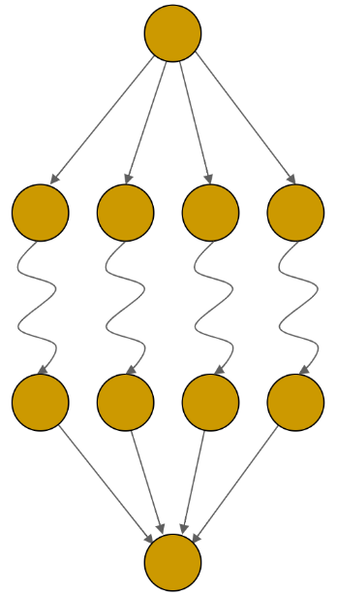

Convergence

Divergence

Transformation

Figure 1: Jones' model of the design process  
(Jones, 1992)

One of the most powerful tools used for understanding game design is the MDA framework. As seen in figure 2, the framework consists of mapping the mechanics, dynamics and aesthetics of a video game to bridge the gap between game design and development, game criticism, and technical game research (Hunicke et al., 2004). It is also useful is discovering the “eight kinds of fun” that can be found within the developed game (LeBlanc, 2004).

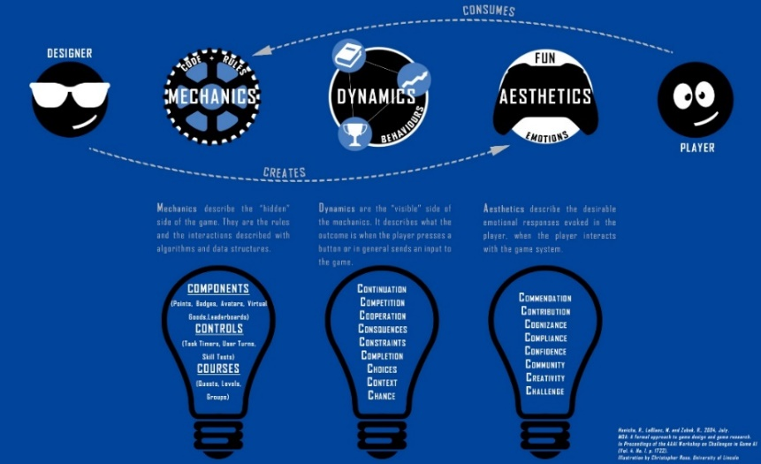

Figure 2: MDA framework (Hunicke et al., 2004)

## Balancing Challenge

Changes to the video games during production or after release normally come in the form of nerfs and buffs, this however is a very controversial topic that has caused a lot of heated debates for a long time (Jaffe et al., 2012). In the game World of Warcraft (Blizzard, 2004), it can be seen when a class such as a warrior, is overpowered, dealing far too much damage and as a result, the class is nerfed. However, to keep the game balanced while also still being fun for the players using this class, the defence of the warrior will be slightly buffed to allow the warrior to output the same amount of damage but over a longer period. By doing this, the other player is now able to survive longer and deal more damage than they would before, ultimately giving them better chance at winning.

Many modern games use a patching technique to adjust game balance by changing the rules, buffing and nerfing, or adding additional content to the already existing content within the game. Patching is the process of changing an existing game and these changes are added on top of it from the player’s perspective, hence the name patch (Kica et al., 2016). Some games are intentionally released without all of its content to allow for additional tweaks. Once complete, a patch is released to change the game with the extra content, adjusting the games rules and tilting the game balance, all of which effectively changes the gameplay for current players (Kica et al., 2016). This is very different to how computer games were released in the past, where all the major content and game features already in place. If bugs were found or improvements were needed, game patches were subsequently pushed out, repairing or improving the game and slightly adjusting the games rules if needed (Kica et al., 2016).

A balanced game is one in which all players begin with an exactly equal chance of victory (DeCoster, 2018). However, balance isn’t and never should be the goal when designing a game. The reasoning behind this is that by having a slightly imbalanced game, developers have discovered that it leads to more compelling and strategic gameplay. Designers are very rarely working to create true balance, but something closer to an equilibrium where a variety of gameplay options exist with each having its own strengths, weaknesses and counter-play options (Millard, 2018).

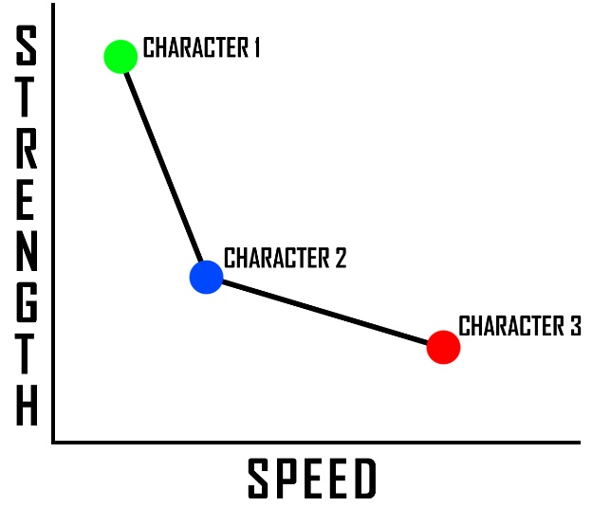There are several reasons why finding this balanced equilibrium is important; player satisfaction; competition; not fun; or spectators aren’t finding it entertaining. Multiplayer games benefit most from balance, this due to player characters being very different from one another and all players need a fair attempt at victory (DeCoster, 2018). One of the most well used methods for finding the best balance in gaming is the pareto frontier.

**Pareto Frontier**

Figure 3: The Pareto Frontier

As shown in figure 3, the Pareto Frontier is a graph that allows the game designer to map attributes such as actions or characters and determine where they are in terms of strength and speed. Once all the attributes are mapped, a line of viability will appear, essentially meaning what is viable, and what is not viable (DeCoster, 2018). By doing this, game designers can accurately determine what attributes a character will gain and what attributes they can give up, giving each character a meaningful difference.

## Control Scheme Evolution

This literature review will focus mostly on first-person control schemes and how they have evolved. In order to accurately determine this, the history of first-person shooter games and their controls will be analysed.

The very first first-person type games were developed in the early 1970s using simple vector graphics (Cummings, 2007). Maze War, being the first of its kind, was a first-person perspective game created by Steve Colley where the aim of the game was to solve a maze. Just as first-person shooters are played today, the perspective of Maze War was in first-person giving the player the impression of being in their avatar’s shoes.

The first-person shooter games of today are designed to closely engage players in violent virtual activities (Jansz et al., 2007) and the first actual first-person shooter game to truly involve visual violence within it, was Battlezone (Atari, 1980). In this game, the player is a tank whose mission was to search and destroy all enemies which include other tanks and spaceships. Later that decade, a game called MIDI Maze (Atari, 1987) made its debut for the Atari ST and from this, true first-person shooters emerged shortly afterward, beginning with popularity gained through the success of Wolfenstein 3D (id Software, 1992) when PCs were beginning to have the power to render textures and true 3D environments (Poole, 2011).

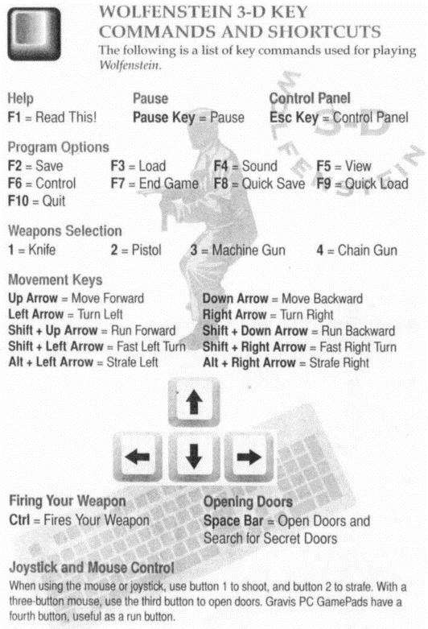The control schemes for these games had to be developed parallel to the games themselves. This means a mapping had to be made to an input device as there was no natural control scheme to simulate walking, unlike driving where a steering wheel could be used. First-person shooters on PC, were all mapped using a combination of mouse and keyboard controls, as they were the only input devices available to all PC users (Cummings, 2007). At this point in time, most first-person shooters only existed on PC due to the superior control methods and customisation available by using the mouse and keyboard.

Figure 4: Wolfenstein Game Manual   
(id Software, 1992)

Wolfenstein is considered by many to be the breakthrough game of the first-person shooter genre (Gkikas et al., 2007), as it has all the aspects of a 21st century first-person shooter, with exception of mouse control and the ability to look up and down. This would not have posed any problems as all the enemies were all on the same altitude as the player. In this game, the player plays as an American soldier who explores a Nazi base and kills mutant soldiers.

The game controls seen in figure 4, were done completely through the keyboard, where the up and down arrow keys would move the player forward and backward, whilst the left and right arrow keys would turn the characters view left and right. The number keys would change the current weapon and the control key would fire it.

As with most PC games, the controls in Wolfenstein were customizable, but most players would have kept the default controls as they had likely never played a game like this before, and hence had no other preference for specific controls (Cummings, 2007).

Doom (id Software, 1993), was even more popular than Wolfenstein 3D and took one more step closer towards true 3D environments by extending playability on to the Z axis. Unlike, Wolfenstein which only used the X and Y axes, Doom used all three by allowing player to rotate their camera up and down by using the page up, and page down buttons. In addition to this, the player was able to climb ladders, use ramps and go up some stairs which allowed them to use this new camera rotation feature. However, by using the page buttons this feature was not very successful as they were inaccurate and slow (Cummings, 2007).

During this time, with the ability to customise control schemes in Doom, some players began testing different methods. One setup in particular, was significantly better and more comfortable than the rest. The WASD control scheme (Gkikas et al., 2007). This involves using the W, A, S, D keys to move the players character rather than the arrow keys and as a result, it improves gameplay by allowing quicker access to number of useful keys for other functions such as weapon change, sprinting, or jumping (Cummings, 2007). This control scheme was still very uncommon during the days of Doom and few players knew about it. However, with the release of quake (id Software, 1996) and its new mouse-look control option, it quickly rose in popularity when the two were combined (Wilde, 2016). Mouse-look (also known as free-look) is a term that describes the ability to move the mouse and control where the player looks in the game (Cummings, 2007). By controlling the avatar’s view, it means that the head becomes independent from the body when looking up or down, however if the player looks left or right, it controls the whole orientation of their body including the head (Gkikas et al., 2007).

With the release of Quake, players began largely experimenting on the different possible control schemes including both the keyboard and mouse. One year after the release, a player named Dennis Fong won the first-ever nationwide Quake tournament in 1997. However, when he won the tournament, he also gave fame to the now traditional WASD control scheme and mouse-look as other player discovered that his right hand was on a mouse, and his left hand was perched over the W, A, S, D keys that are now considered synonymous with PC gaming (Wilde, 2016). Both the WASD control scheme and the mouse-look were the most significant technical breakthroughs of the mid-1990s and are considered the last great evolutions in the first-person shooter genres still in use today (Cummings, 2007).

As gaming consoles were becoming a very popular household item, developers began thinking of new ways to bring to consoles, a more accurate way of controlling a camera and a character in a 3D environment without the need of a mouse or keyboard (Cummings, 2007). As a result, controllers using analogue sticks were developed which significantly assisted in bringing first-person shooters to consoles, which still had d-pad controllers making movement and aiming very slow with a lack of any acceleration and overall less accurate than what was required (Klochek et al., 2006), this was due to a d-pad being able to only move in one of the four directions or at diagonals if the design of the d-pad allowed it (Cummings, 2007).

Finally, to increase player experience and usability, an aim-assist technique was developed and is used in many first-person shooters. When the player is aiming near an “agent” that is a target or enemy the game will slowly assist the player by moving the reticle towards that target. Studies have suggested that technique works well in balancing a player’s expertise and enjoyment when the aim assist technology is added into their first-person shooter game (Vicencio-Moreira et al., 2015).

## Fitt’s Law

This section will focus mostly on Fitts’ law (Fitts, 1954). A thorough analysis of Fitt’s Law shall take place to determine what it is, and how it can be used in the development and design of a first-person shooter.

Fitts’ Law is a predictive model of human movement mainly used in human–computer interaction and ergonomics. It predicts that the time required to rapidly move to a target area is a function of the ratio between the distance to the target and the width of the target, meaning it is faster to hit larger targets that are closer rather than small targets that are further away (MacKenzie, 1992).

The Fitts law model has been developed mathematically using several different methods. The most common method is known as the Shannon formulation (Mackenzie, 1991)

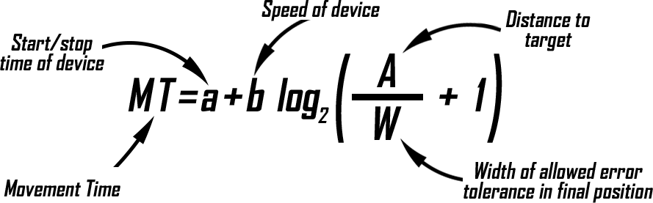

Figure 5: Fitt's Law - Shannon Formulation (Mackenzie, 1991)

Looser (2005) states that linear regression is used to determine the line of best fit, between the Movement Time (MT) and the Index of Difficulty (ID) (Looser et al., 2005). The calculation to this can be seen in figure 5 where MT = a + b × ID, and ID = log2(A / W + 1).

It is a highly important law when it comes to game development as it provides designers with the highlighted areas of importance when it comes to target acquisition. The Fitts law equation highlights pointing speed, target distance, target size and accuracy when developing pointing tasks, in this case developing a first-person shooter (Looser et al., 2005).

In conclusion, Fitt’s Law demonstrates that there is a difference between the distance of the target and the size of the target when it comes to accuracy. This affects how long it takes for a player to aim and can be measured by how far away the target is from the player as well as how big that target is. Thus, the longer the distance and the smaller the target is, the more time it will take for the player to aim (Looser et al., 2005).

# Methodology

## Project Management

This section will detail the methodology used to complete the project.

Zimmerman (2003) stated that a game is a software application in which one or more players can make decisions by controlling game objects and other resources, in the pursuit of its goal (Zimmerman, 2003), and as with all software applications, the process of developing one can be eased by using software engineering methodologies. The testing stages will also be considered when choosing the best method to use for developing the first-person shooter.

As stated in objective 2 in the aims and objectives section, an agile approach will be taken as most of the requirements are not defined before the project begins and throughout the project they will changing on a regular basis. As this is the case, the Waterfall methodology is automatically excluded as it is a plan-driven process that happens one step at a time (Schwaber, K., 1997). Each phase of development in this method has distinct goals and must be completed to the best standard before the next stage commences and once started, it is very difficult to return to a previous step. Marco (2017) also states that the waterfall model is efficient only for those doing a very small project (Marco, 2017).

Agile methodologies are the most commonly used methodologies in game development. These methods are highly iterative and not documentation-centric (Godoy et al., 2010).

The evolutionary development methodology is an agile method where each iteration is a miniature software project of its own and includes all the tasks necessary to release the mini-increment of new functionality: planning, requirements analysis, design, coding, testing, and documentation (Larman, 2004). During the beginning phase of each iteration, the whole team will meet and discuss new objectives and at the end of each iteration, the results are communicated to clients. The most used methodologies in game development are extreme programming and scrum (Godoy et al., 2010).

Extreme Programming or XP (Beck et al., 2000) aims to produce higher quality software, with an easier development process for development teams. XP is the most specific of the agile methodologies regarding appropriate engineering practices for software development. There are several practices that can used when using XP, however the two most used practices are “Pair Programming” and “User Stories” (Wells, 2013). However, this methodology was chosen as development teams should be more than one to get the most out of extreme programming (House, 2015).

The Scrum Agile Methodology was considered as it one of the popular methodologies used in game development and goes by the name of Game-Scrum (Godoy et al., 2010). This is a process that is broken down into iterations, more commonly called sprints (Schwaber et al., 2002). During these iterations, the development team will use a Scrum board and backlog to assist in implementing, testing, and reviewing what was planned. This methodology, like extreme programming, requires a team, management and a product owner, all of which are non-existent.

The spiral model as seen in figure 6, is described as being flexible and interactive, bringing a number of benefits to various projects of any size (Marco, 2017). It is designed to keep risks as low as possible by using iterations called cycles. During these cycles a number of changes can be made quickly and efficiently (Larman et al., 2003). Marco (2017) states that during the first cycles, it is important to dedicate these to developing the core features of the game, this allows the developer to quickly discover if something is wrong with the core game mechanics (Marco, 2017).

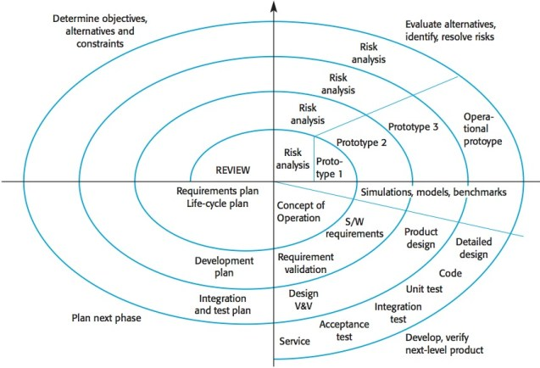

Figure 6: The Spiral Model (Boehm, 1986)

The pros and cons of the spiral model are as follows:

|  |  |
| --- | --- |
| **Pros:**   * Risk factors are considerably reduced * Excellent for large and complex projects * Allows for additional functionality later * Suitable for highly risky projects with varied business needs. | **Cons:**   * Costly model in software development * Not appropriate for low-risk projects * Might get continued and never finish * Failure in risk analysis phase may damage the whole project |

In conclusion, both the evolutionary and the spiral methodologies were considered due to their numerous benefits including speed and risk identification and therefore a mixture of both will be used to develop the game through iterative cycles. As most of the project requirements are unknown, the low risk benefit of the spiral will provide the best results while the evolutionary will increase the speed of development. This is possible as there is only one developer with no team or management, meaning that there is freedom to change some aspects of a methodology to suit the needs of the project and allow maximum productivity with the least amount of stress.

## Project Plan

For the planning of the project a Gantt chart has been used to visualise the time frame of the project. Maylor (2001) states that the tool encourages a one-step approach to planning due to the practise of using different colours, meaning that they are clear and precise. This can result in staff being unwilling to challenge the charts, and so they gain a momentum all of their own. It can also encourage project managers to over-control the project rather than devolve the responsibility for the time-plan to team members (Maylor, 2001).

The project plan has been split into two pieces, the artefact and the documentation.

The red colour is used to show which higher section of the chart is being worked on at that time. For example, to find what is being worked on during the second week of December, the red line is followed first and then the orange is found below. According to the Gantt chart the task to review and organise all previous research will be in progress during that week and will end after the third week of December. Tasks where given very generous time frames as this keeps the overall plan of the project relatively stress free.

The project will make use of a Spiral methodology where development will take place through iterations or cycles of the artefact and do further testing after each iteration. Following this methodology, an iteration has been set in to four stages: planning, design, implementation and finally the testing.

During the development of this artefact an iteration will begin with the first stage of gathering all the desired requirements, and once they are clearly described, the objectives are then identified, elaborated and analysed. The second stage involves designing, identifying and evaluating potential risks within the plan, these issues are then resolved using the best possible strategy that was discovered during the evaluation.

Once content with the planning and design completed in previous stages, the third stage is begun by developing and testing the identified features. Finally, the project is then reviewed and planning for the next iteration is started.

The stages documented in the Gantt chart are as follows:

* During the planning stages, research will take place to discover what makes first-person shooters popular and what are the most relevant features that helped them achieve success. The evolution of first-person shooters will also be researched, looking into how they evolved, adding features, actions, and user interface elements that are needed in every game today.
* The design stage will involve discovering the features needed and documenting them. It will also involve drawing diagrams, sketching maps, designing enemies and their abilities, and finding or creating any required game models.
* Once the play testing stages begin, test participants will be required to play through the first game and upon completion, they will be asked to complete a questionnaire. Once complete, the same process will be completed for the second game with simplified controls. As the testing period is nearing an end, the test results will be documented, a conclusion will be drawn, and all questionnaires will be destroyed along with any personal information that may have accidentally been acquired.

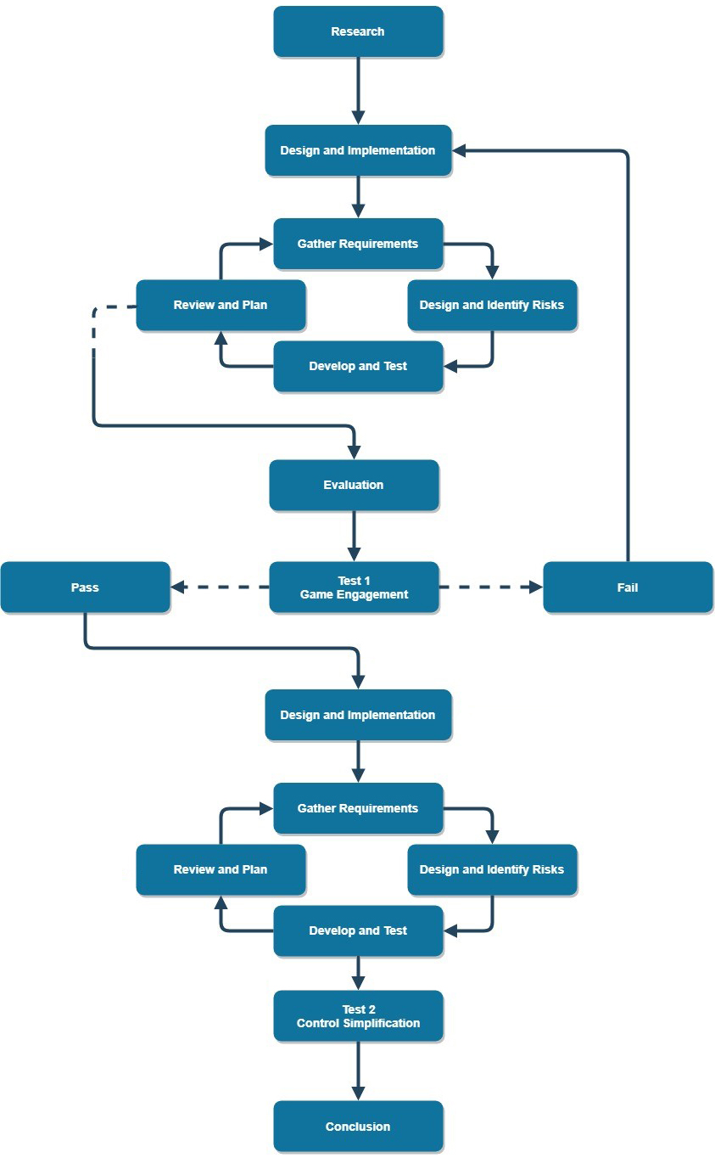

Figure 7: Project Flowchart

The project flowchart as seen in figure 7, begins with research and proceeds onto design and implementation which involves the spiral methodology where it can be seen in the form of a loop. This loop will continue to iterate until the artefact is reviewed and found to be complete. An additional risk assessment was also carried out during the design and implementation stage, as further risks may have appeared half way through the creation of the game.

From this point, the artefact will progress on to be evaluated where the very play test will take place to determine how enjoyable the game is to play. If the test discovers that a majority of participants did not enjoy playing the game, the design and implementation process will recommence. However, if it is a success, the second testing stage will be performed to investigate the effects of simplified controls on the two versions of the game.

The conclusion for the project will be drawn during and after the second play testing stage. This will involve organising, analysing and documenting all the data collected from test participants. An especially generous time frame has been given to this task which can be seen on the Gantt chart in figure 8 and this will allow extra time to review the project in total once complete.

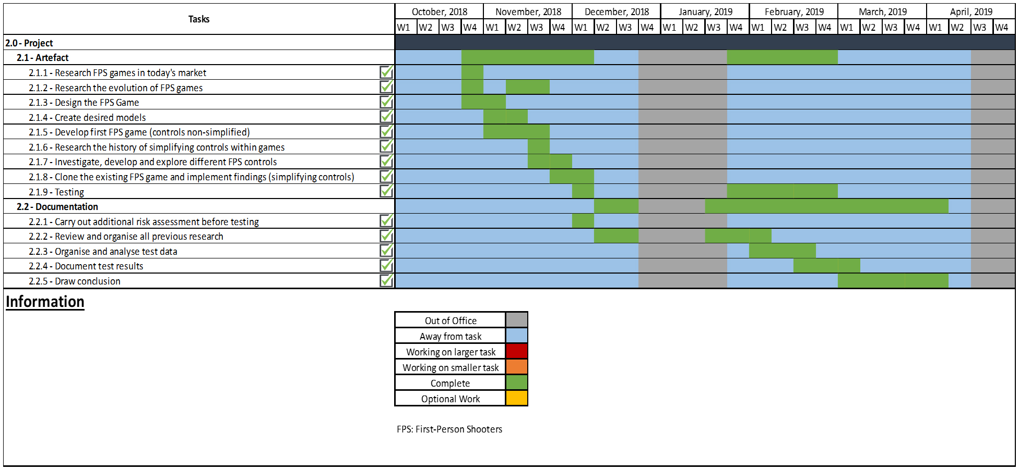

Figure 8: Gantt Chart

## Tools

During the project, a number of tools, toolkits, and languages were used to attempt to facilitate the development of the artefact.

### Development Tools

#### GitHub

GitHub Desktop (Microsoft Corporation) as seen in figure 9, was a vital tool used throughout the development process and comes with a number of useful services including version control, sharing, and branching. When any issues occurred during the process of developing the artefact, this tool was instrumental as it could revert all changes back to a previous state.

Having the ability to view any earlier commits through the applications history was also extremely beneficial, as this made it possible to view previous iterations of code. Each time an element is committed and pushed to GitHub a new log is created.

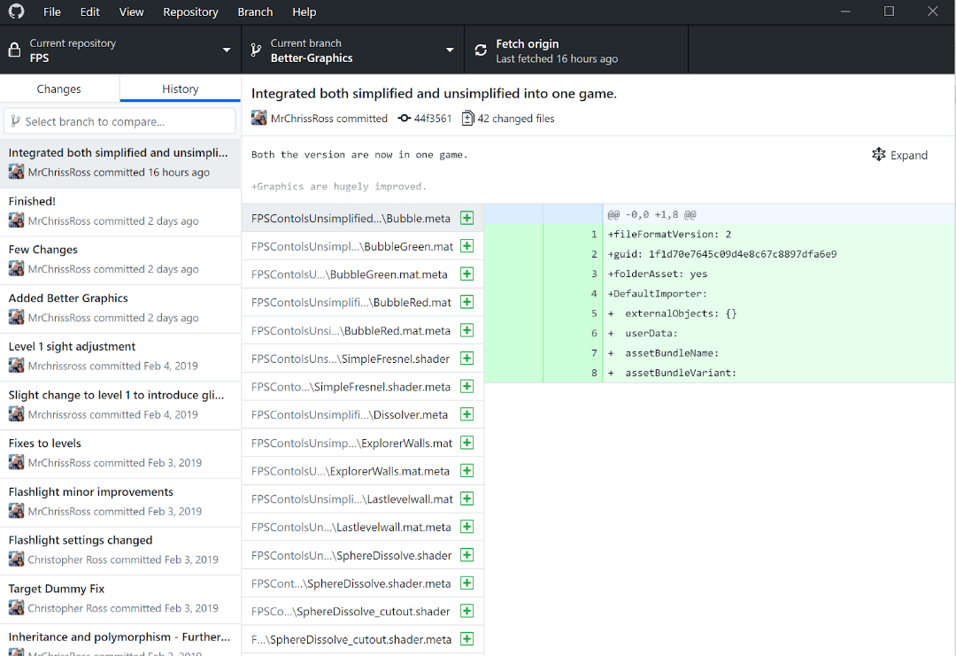

Figure 9: GitHub Desktop

This tool was especially helpful when pieces of the code had been unintentionally deleted from the repository, and by using the history tab, it is possible to quickly recover any missing code. This resulted in countless hours being saved in re-implementing what was deleted.



Figure 10: GitHub Commit

GitHub’s branching tool is also very useful, as additional environments were able to be created, where new concept ideas and features can be implemented and tested. The changes that are made on this different branch will not affect any of the other branches that may exist, meaning developers have the freedom to experiment and commit changes, safely without any fear that it may affect vital code.

#### Unity Game Engine

The Unity game engine (Unity Technologies, 2005) has been chosen to develop the game due to its numerous benefits which include high quality documentation, a large developer community, a very interactive editor, built-in physics and rendering, cross-platform distribution and an asset store (Craighead, 2008). This game engine will be analysed in further detail to determine how each of the noted elements can increase the chance of success of the artefact.

Regarding documentation, Unity comes with what is called a Unity User Manual, this can be seen in figure 11 and includes many examples in coding and using its software (Haas, 2014). This is significantly better in comparison to other engines where only partial documentation is provided to non-paying customers (Craighead, 2008) and as a result, having this documentation will increase productivity and provide immense support in developing the game.



Figure 11: The Unity User Manual

Unity has one of the biggest developer communities in the world who are always available to help users who are new to the software. This has been one the biggest benefits of using unity since its launch in 2005 (Haas, 2014), with even the Unity Technology developers themselves being available and occasionally adding new features at the community’s request and by having such a large community who swiftly reply, this additional support will be very useful in the event of issues arising during the development of the project.

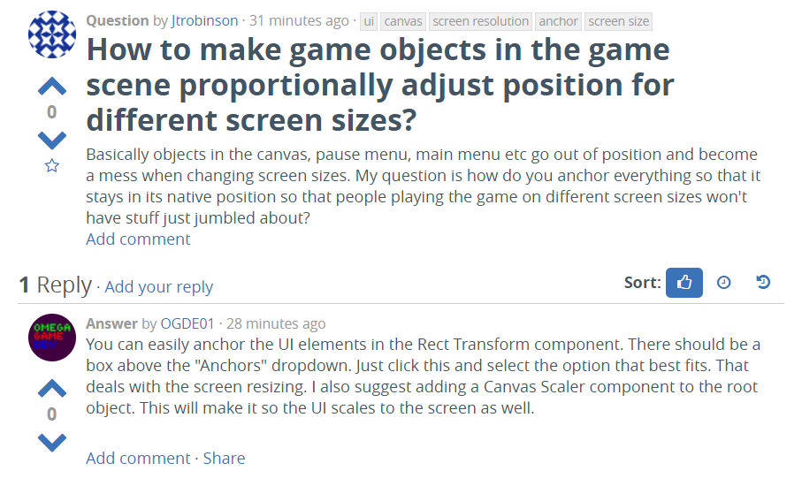

Figure 12: Unity Questions

The game engine’s editor is by far the easiest to use when compared to other game engines such as Unreal, Source, or Torque (Craighead, 2008). Content is listed in a sub-window called “Project” and the elements within can added into the scene through a drag and drop manner, this can be seen in figure 13. Objects that are inside the scene are listed within the inspector sub-window where multiple scripts written in C#, a JavaScript-like language can be assigned. This greatly assists in the management and organisation of the artefact and by having a game engine that is easy to use, this will make development less stressful while increase the speed of production.

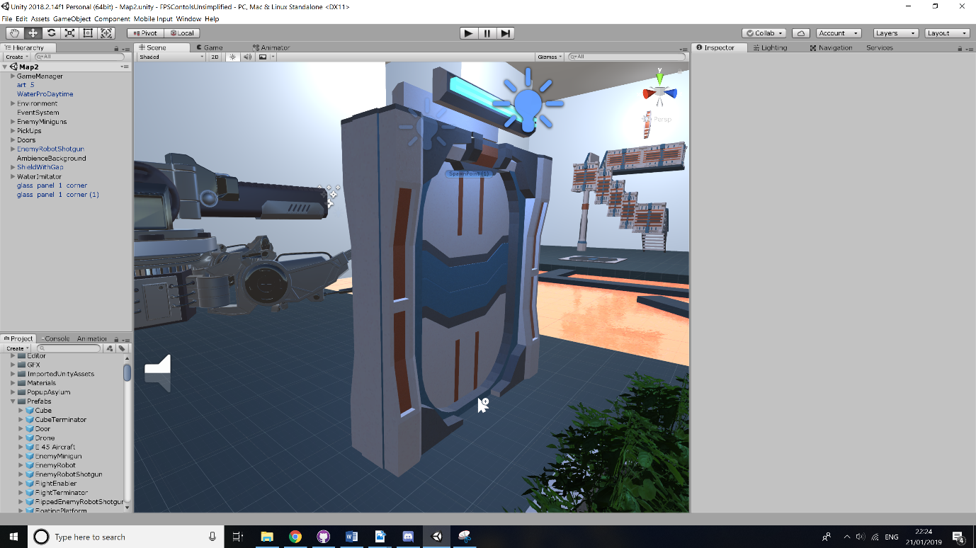

Figure 13: Unity Game Engine

The physics properties within Unity are simulated by NVidia’s PhysX engine, this allows objects to have realistic physics such as mass, drag, springiness, bounciness, and collision detection as well as be assembled using a variety of joints (Craighead, 2008). The rendering properties include shader and texture assignment which affect the appearance of visible objects. Unity’s custom rendering engine uses a simplified shader language and as of 2015, it is compiled into DirectX 12 or OpenGL 2.0 shaders depending on the target platform (Jakubauskas, 2015).

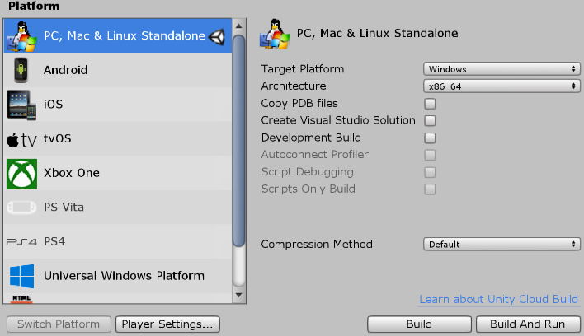As seen in figure 14, applications created using Unity can be compiled to run on various platforms, having no restrictions on any distribution. Craighead (2008) states that this is due to applications not being modifications of any existing games and therefore the end user does not need to own a copy of anything. Complete binaries can simply be distributed as the developer wishes (Craighead, 2008). This can be very useful to the project as a stretch task to discover how control schemes differ between different platforms and an additional test regarding this could take place.

Figure 14: Unity Build Settings

### Development Environment

#### C# Programming Language

As the project will be entirely developed through the Unity Game Engine, C# will be the programming language used to complete this project. In previous versions of the Unity, it offered the option to use either C# or JavaScript, however this option has been removed and C# is now the most supported language with a vast amount of resources available from the community.

#### Visual Studio

Microsoft Visual Studio (Microsoft Corporation, 1995) is an IDE (integrated development environment) that is used to assist in the creation of various types of programmes ranging from web and mobile applications to video games. This IDE comes with a number of supported languages such as: JavaScript, C#, C++, F#, and many more.

This IDE is an extremely useful tool in the development of the artefact as it works in parallel with the Unity Game Engine, allowing its users to navigate and modify their scripts. Two of its most powerful features is its IntelliSense and debugger.

The IntelliSense assists developers by providing them with an option to auto-complete the rest of certain elements of their code. This was incredibly valuable when developing the game using Unity where certain functions may appear that would have otherwise been forgotten. Additionally, the debugger aided in identifying issues by setting various breakpoints and evaluating variables or other complex expressions.

#### Photoshop

Photoshop (Adobe Inc., 1990) is a raster graphics editor that provided significant assistance in the creation of UI elements, textures and other 2D objects that were vital to the success of the game including an instructions menu at the start.

#### Blender

Blender (Blender Foundation, 1998) is a 3D modelling tool that is also capable of creating animated films, various visual effects, art, 3D printed models, interactive 3D applications and video games. This was a valuable tool that was used in the developing most of the models for the game.

#### OBS

OBS (Bailey, 2012) was used to record high quality footage of the game window whilst participants were playing. It is most useful to record where and how players are most likely to succeed and/or fail.

### Evaluation Tools

#### Microsoft Office

Microsoft office (Microsoft Corporation, 1995) was very useful as it comes with a number of tools including word and excel. This grew in usefulness once the results were acquired, where excel assisted in gathering statistics and creating tables, graphs, and charts.

#### Google Forms

This was used to create the questionnaires and provides participants with an easy way to access the questionnaires from any computer.

## Testing

To perform the tests, participants are recruited in person at the University of Lincoln. None of their personal information is taken and they are made fully aware that only their gameplay would be recorded during the control scheme tests, they are also assured that they can withdraw at any point without filling in any of the questionnaires.

Rather than taking participants names and email addresses, an alternative method was used where they are assigned a number to ensure their questionnaires can be matched with each other and their results not becoming skewed.

### Enjoyment Test

During the enjoyment testing stage, eight participants are required to play the developed game until they complete it which is expected to take between 20 to 45 minutes depending on how experienced the player is at playing first person shooters. Players will have the choice between choosing to play the game using a keyboard and mouse or an Xbox gamepad which they are able swap between at any point during the game, this was only an option as the quality of the game is being tested rather than the controls.

Once a participant has reached the end of the game, they are asked to fill out a questionnaire, this can be seen in the appendices item 1 and can be used to calculate the overall enjoyment.

The participant begins by entering their participant number which is provided before starting the questionnaire. Most questions are answered using the Likert Scale (Likert, 1932) as seen in figure 15, where they may choose between five options ranging from strongly agree to strongly disagree. An additional comment box will also be available underneath the question for participants to leave an optional remark on why they chose what they selected which can then lead to additional improvements on the game.

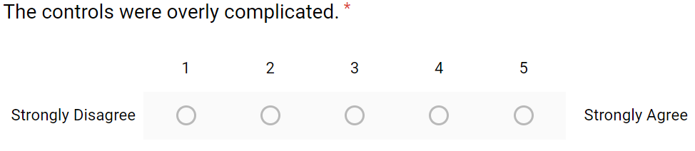

Figure 15: Likert Scale

The results from these tests will be analysed and if the results are negative, development will continue to iterate until the results are overall positive, in which case the control scheme testing will begin. With each iteration, changes were also made to the questionnaire to improve the quality of the information received and as seen in appendices item 2, qualitive questions were added to the beginning, asking for a general impression and to explain what they did not like about the game.

The questionnaire was also separated into two sections to avoid any Likert questions influencing the participants answer when responding to the qualitative questions. The question regarding how experienced the participant is in playing first-person shooters was also separated into two queries: how experienced they are in playing games in general, and then how experienced they are at playing first-person shooters. This was done to gain a deeper and more precise understanding on exactly how much experience participants may have allowing better categorisation into appropriate groups.

### Control Scheme Test

Upon completing the enjoyment test and receiving positive feedback, two almost identical games will be played by thirty participants to test and evaluate the simplification of first-person shooter controls. All thirty participants will begin by playing the non-simplified version with typical first-person shooter controls, this ensures that all participants start under the same circumstances.

Similar to the game enjoyment tests taken before, when participants have played for ten minutes or have reached the end of the game, they will be asked to complete the questionnaire. Both versions of the game will have identical questionnaires that are split into three sections where participants are asked a series of qualitative and quantitative questions and a fourth section will be presented once both questionnaires have been completed.

The first section, as seen in appendices item 3, consisted of gathering qualitative information regarding their experience playing the game such as their general impression, what they liked about the control scheme, what they did not like and how they could improve them. It was structured to provide two opportunities to gain positive insights into what they liked about the control scheme and three opportunities to gain negative insights into what they did not like about the control scheme

|  |  |
| --- | --- |
| Insights | |
| Positive | Negative |
| * What was your general impression […] * What do you like most about […] | * What was your general impression […] * Were there any areas where you […] * What would you add to improve […] |

Figure 16: Insights

The second section focuses on how much previous experience the participant has in playing games in general and more specifically first-person shooters. An additional question was added into this section to determine whether the controls were comfortable given the participants previous experiences in playing other games or first-person shooters. It thus provides an opportunity for the participant to reference and compare other games to this game and how their control schemes may differ.

In the third and largest section, participants answer using the Likert Scale, similar to the previous enjoyment tests where they have the choice between five options ranging from strongly disagree to strongly agree. The answer the participant chooses will vary depending on how well they agree with the statement which will be will be displayed as if the participant themselves were saying it.



Figure 17: Control Scheme Test - Section Three

Once all the questions have been completed and if they have not completed the other version of the game, they will then be requested to play it repeating the process. Otherwise they will be presented with the fourth section of the questionnaire which will determine which version of the game they preferred the most and why.

## Research Methods

This section will seek to investigate and justify the different types of research methods necessary to validly answer the research questions that are addressed within the project.

The data collected from the questionnaires will be ordinal as the Likert scales will be used within the questionnaires and each answer will have a numerical value to enable categorisation.

For this project, the mixed method research methodology will be used as both quantitative and qualitative data will be gathered from the participants who partake in the interviews and questionnaires (Wisdom et al., 2013). Both these research methods are essential in answering the research questions posed throughout the project and will be very useful when one technique is limited in a specific area where another isn’t.

As a result, this methodology will strengthen the reliability of data gathered and the validity of the findings by combining and analysing the statistical data with deeper contextualised insights. It broadens and deepens the understanding of processes through which program outcomes and impacts are achieved, and how these are affected by the context within which the program is implemented (Bamberger, 2012).

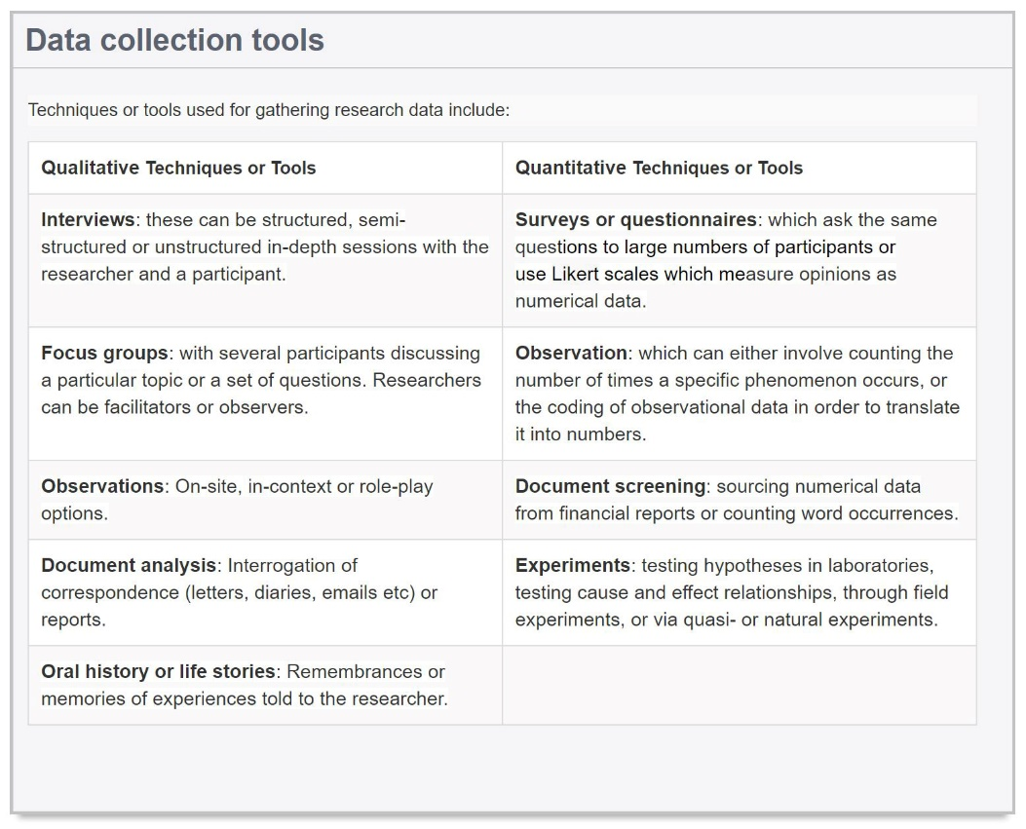

Figure 18: Research Methods (University of Newcastle, 2019)

Jennifer Wisdom (2013) states that while there are many benefits to using mixed methods, it can also drastically increase the complexity of evaluations in terms of planning and conduct. Additional resources may also be required in comparison to a regular single method study as it requires both time and material to do both the quantitative and qualitative methods Wisdom et al., 2013).

# Design

## Lo-Fidelity Prototypes & Sketches

Low-fidelity (lo-fi) prototypes are rough representations of concepts that help validate concepts early in the design process. These types of prototype will greatly assist in the design and creation of the artefact as they can easily be created by a single individual with no dependency on skill (Busche, 2014). It can be used to translate high-level design concepts into tangible and testable artefacts and as a result it will significantly improve the speed and quality of work produced (Babich, 2017).

The lo-fi prototypes also work incredibly well with agile design methodologies where iteration is key in a truly agile design process. Laura Busche (2014) states that only by continually evolving our concepts will we be able to create empathetic solutions that will succeed in the current market. Low-fidelity prototypes encourage this type of shameless, stress-free environment of iteration. Making sharp changes, pivoting to a new business model or even starting from scratch feels more natural to us because there is simply not that much to scrap (Busche, 2014).

### Sketches

These sketches provide an overview of the different ideas that came mind when planning the design of the game. As seen in figure 19, initial ideas were formed where the game would take place in a desert and this then changed into a prison where further ideas of game objects were designed, however flaws and risks were identified and removed. As the risks were slowly removed, ideas of the game taking place in a futuristic setting with robots being both the player and the enemies. Drawing 6 in figure 19, the game Portal (Valve Corporation, 2007) became an enormous inspiration for discovering further ideas.

|  |  |
| --- | --- |
| C:\Users\Student\AppData\Local\Microsoft\Windows\INetCache\Content.Word\20190205_011016.jpg  Figure 19: Sketch Ideas, Game Evolution, and Player Abilities | C:\Users\Student\AppData\Local\Microsoft\Windows\INetCache\Content.Word\20190205_011050.jpg  Figure 20: Game Object, Feature, and Floor Plan Creation |

### Experience Flow Diagram

|  |  |
| --- | --- |
| Figure 21 shows an experience flow diagram where each screen in the game is visualised. It displays simple flow of what the game will look like when it is implemented and how it will be played. | 20190205_132840  Figure 21: Experience Flow Diagram |

### Storyboarding

|  |  |
| --- | --- |
| During the design of the game, a storyboard was implemented and can be seen in figure 22. Each story goes through a situation that a user other than the designer may come across during a playthrough of the game. This is an attempt at thinking of what a first-time player would do and as a result flaws in the design were discovered and fixed. | 20190205_135952  Figure 22: Storyboarding |

### One Page Design Document

The one-page design document is considered one of the quickest ways of portraying a complete understanding and concise design onto its viewers (Osorio, 2016). Librande (2010) states that people aren’t always willing to read thousands of words to understand a simple concept and with the one-page design document it has the potential to eliminate hours’ worth of reading. It provides a far easier and less complicated method of communicating ideas to an audience (Librande, 2010).

In order to successfully create a one-page design document, the requirements of the game must be known for the content to be detailed. Librande (2010) suggests doing various sketches and lo-fi prototypes before attempting to create a design page to assist in understanding how the user will play the game. The prototypes help identify different possible experiences that the player may have, and this allows the designer to portray these in the document (Librande, 2010).

Osorio (2016) states that the documents should have three key factors. It should be brief where it provides a quick and clear idea about the game. It should be clean and ordered where the readers are able to flow smoothly through the document and finally, the document should have its own visual identity where it should stand out and leave a mark in the audience (Osorio, 2016).

By having this document printed, it will be extremely useful when explaining to participants the game rules, features, and objects that the player will encounter throughout the game. It could also be beneficial to show the public in general, as better ideas may be pointed out or flaws can be found where improvement is needed. This document will also serve as an additional reminder of the players abilities in case participants forget.

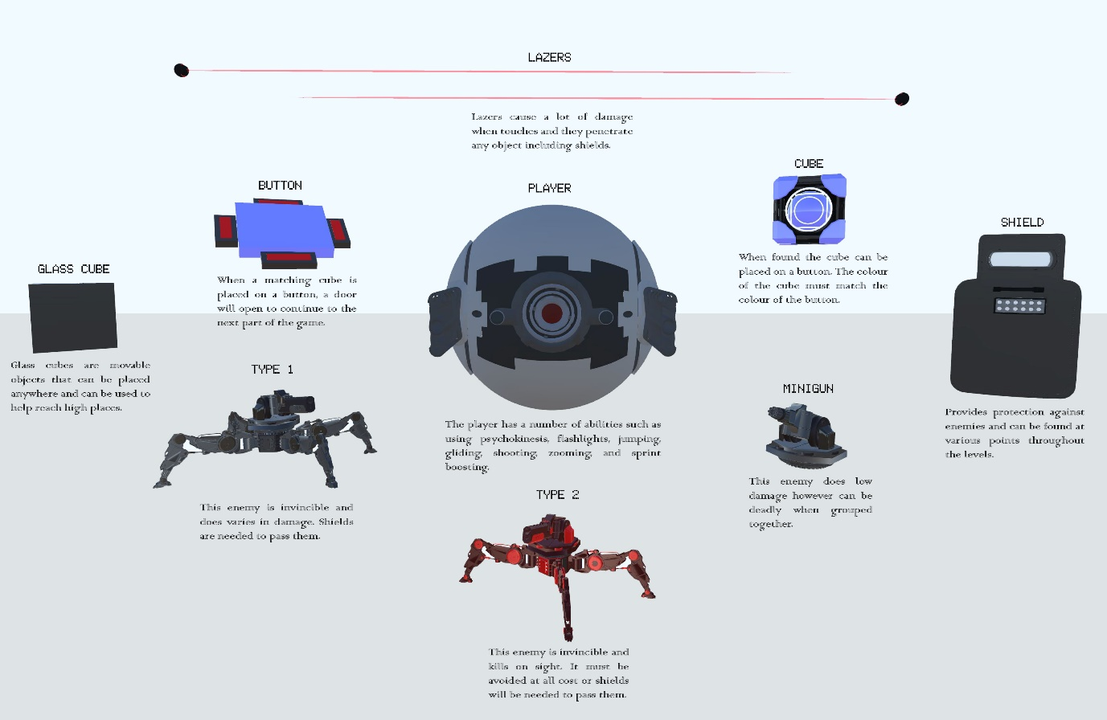

Figure 23: One Page Design Document

## Game Design Document

### Mechanics, Dynamics and Aesthetics

To assist in the design of the game, a Mechanics, Dynamics and Aesthetics (MDA) analysis was done to assist in discovering new ideas and what exactly the ideas bring in terms of enjoyment to the user. In figure 24, the first column displays the mechanics of the game, the second shows the dynamics and the third shows which “kind of fun” the mechanic and dynamic generates.

As an example, the mechanic “picks up object” (mechanics found in column one), will allow the player to “use protection” through shields or “use a cube to press buttons” (dynamics found in column two). From using shields this brings “challenge” to the game, and by finding and using cubes, the discovery aesthetic is brought to the game (aesthetics found in column three).

It is worth noting that the dynamics are constantly changing depending on how players use a specific mechanic, as they are always discovering new ways of using mechanics even when these mechanics were never originally intended to be used in such a way (Hunicke, R. et al. 2004).

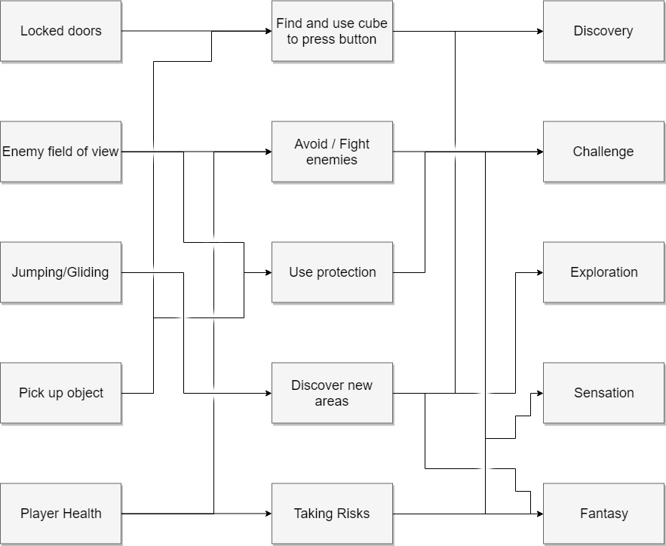

Figure 24: MDA Framework

### Game Features

By reading the aims and objectives, completed background research, and literature reviews it can be ascertained that the game should have certain features. These features can be seen below:

#### Main Features

|  |  |
| --- | --- |
| * Played in first-person * Easy to learn with a gentle learning curve. * Must be able to play with keyboard and mouse. * Player shooting. | * + Contains enemies.   + No living creatures.   + Very challenging.   + Audio. |

The main features of the game are:

#### Player

The player will have the ability to:

* Move and rotate around a 3D space.
* Aim and zoom.
* Interact with objects (i.e. pick up object)
* Jump and glide.
* Pause the game.
* Change mouse sensitivity settings.
* Be destroyed by various object and enemies.
* Respawn.
* Use a flashlight.

#### Game Objects

Figure 25: The Player

The game will contain a number of objects and enemies:

* Cubes.
* Glass Cubes.
* Doors.
* Buttons.
* Shields.
* Floating Platforms.
* Signs

Figure 26: The Cube

#### Enemies

* Target Dummies.
* Enemy Type .5.
* Enemy Type 1.
* Enemy Type 2.
* Lasers.
* Water.
* Force fields destroy or protect object within the game, including players and enemies.

Figure 27: Type 2 Enemy

### Game Controls

#### Non-simplified Controls

|  |  |
| --- | --- |
| C:\Users\Student\AppData\Local\Microsoft\Windows\INetCache\Content.Word\Keyboard Uns.png  Figure 28: non-simplified Keyboard Layout | C:\Users\Student\AppData\Local\Microsoft\Windows\INetCache\Content.Word\Mouse Uns.png  (Scroll)  Figure 29: non-simplified Mouse Layout |

The controls for the non-simplified version of the game can been be seen in figures 28 and 29 where a typical first-person shooter control scheme is used. This control scheme has been discussed in further detail in section 3.4 and involves using the *W, A, S, D* keys to move the players character, *E* to interact with objects, *Q* to glide whilst the player is in the air, *Space* to jump, and *Shift* to move at a faster pace than usual at the cost of fuel.

#### Simplified Controls

The Simplified version of the game has a control scheme that is very different to the version mentioned above. Initially it was intended to keep the *W, A, S, D* layout however after play testing the simplified version for the first time, it was almost immediately noted that the players without any prior gaming experience would automatically attempt to use the arrow keys to move and once told to use the *W, A, S, D* keys, they were unable to do so without looking at the positioning of their fingers every few seconds.

During this short play test of five people, no questionnaires were completed as it was done purely to observe and discover exactly how participants would initially attempt to move, shoot, and use other game mechanics. As a result, and after further consideration, the choice was made to revert back to the old way of using the arrow keys. By doing this, it meant having to rearrange every button from the left side of the keyboard to the right side. This was done by combining, automating, or removing some of the inputs.

The input that was removed for the simplified version was the sprint mechanic, and this was instead made into a passive ability. A passive ability is an ability that doesn't require input from the player to be used and is a common concept used in many games such as World of Warcraft (WowWiki, 2004) and Overwatch (OverwatchWiki, 2016). This sprint mechanic was integrated into the normal movement of the player which resulted in a speed increase of 4%.

The shooting mechanic was the input that was automated. This was done by making the player’s character automatically shoot when they are looking directly at an enemy with their crosshair pointing at them.

Additionally, to ease the aiming process for a player with no prior gaming experience, Fitt’s law (Fitts, 1954) has been used to assist in the implementation of an aim assist function. This function comes into effect when the player’s crosshair is over a target and will drastically reduce the sensitivity of the player’s cursor or the speed at which the camera moves. Although the target does not become any bigger it does however increase the space and probability in which a successful shot can take place from the player.

The two inputs that were combined were the jump and glide mechanics where in the non-simplified version it was required first press the jump button and then the glide button. However, in the simplified version of the game both these functions take place by simply holding down the one button.

Finally, the flashlight input was simplified where instead of using the mouse wheel and scrolling up to incrementally turn intensity of the flashlight up, it will simply click on to a set intensity by clicking the same button. However, as a result of this change the player is no longer able to set their own intensity resulting in the flashlight being possibly too bright when looking closely at an object in the dark.

The changes to the control layout can be found in the following figures:

|  |  |
| --- | --- |
| Figure 30: Simplified Keyboard Layout | C:\Users\Student\AppData\Local\Microsoft\Windows\INetCache\Content.Word\Mouse Sim.png  (Click)  Figure 31: Simplified Mouse Layout |

## The Final Product

With all game objects created, shaders made, and rules implemented. The final version of the game was created to not only be fun but also as visually appealing as possible. The following screenshots of the game present what has been has been achieved.

The main menu gives the player three options, where they may choose to either play, see the control configuration, or tweak the games settings such as graphic quality volume or mouse sensitivity.

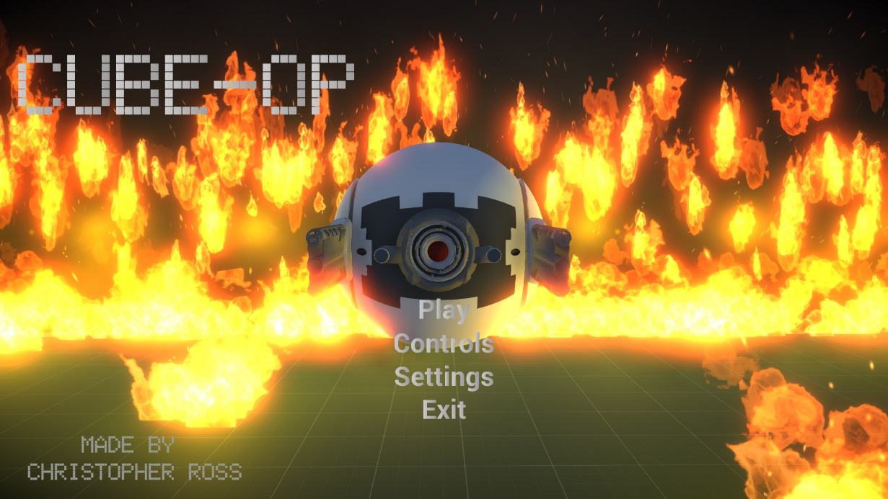

Figure 32: The Main Menu

The decision was taken to merge both versions of the game together and providing an option to choose whether the game is in simplified mode or not. This can be seen at the bottom right corner of figure 33.

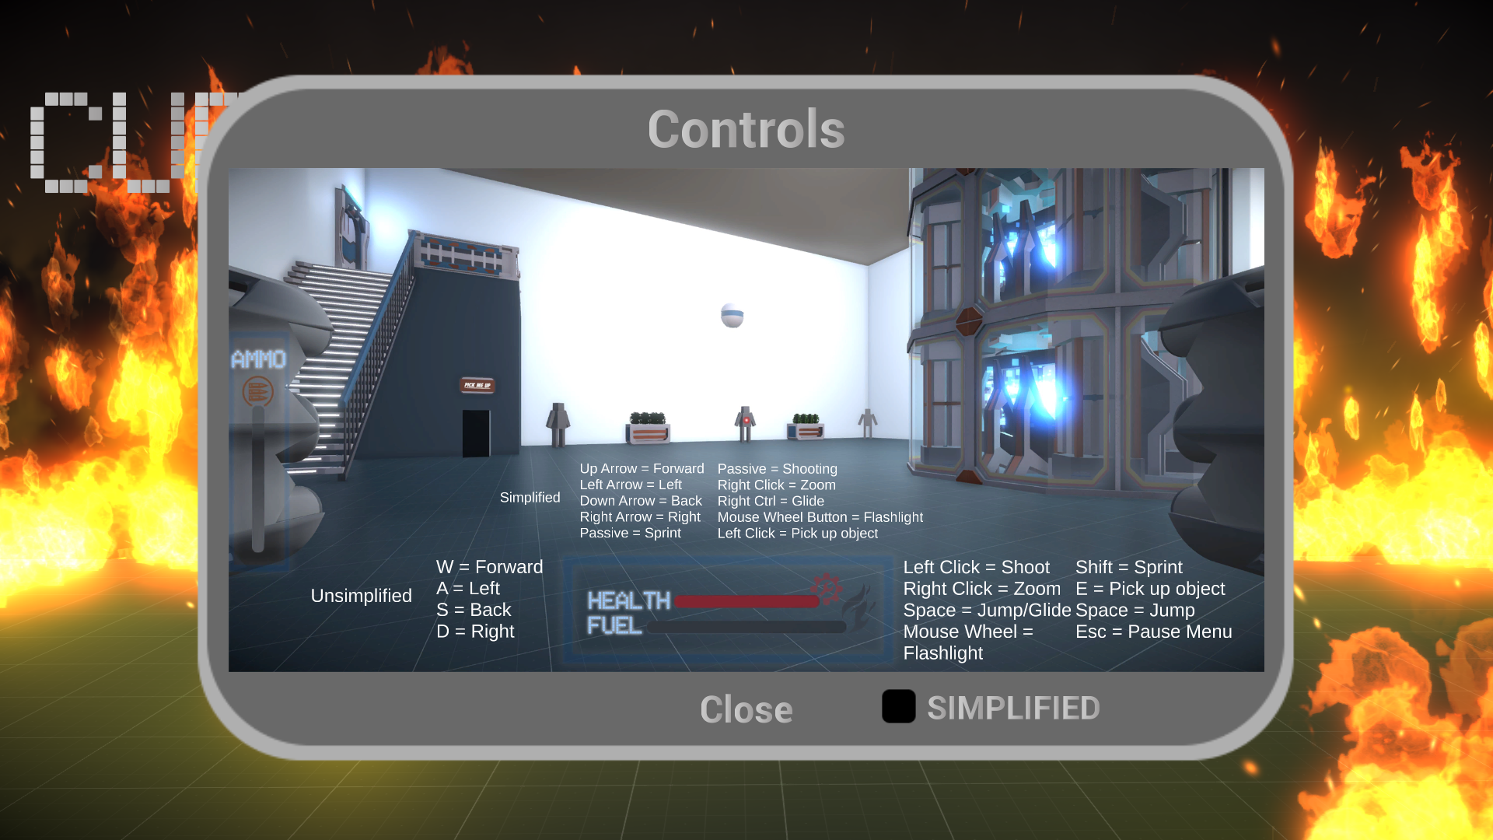

Figure 33: Controls Menu

Within the game signs are located throughout and give tips and other types of information to the player whilst exploring the level. Depending on the importance, a message may appear on the player HUD (Heads Up Display) or UI as seen in figure 34.

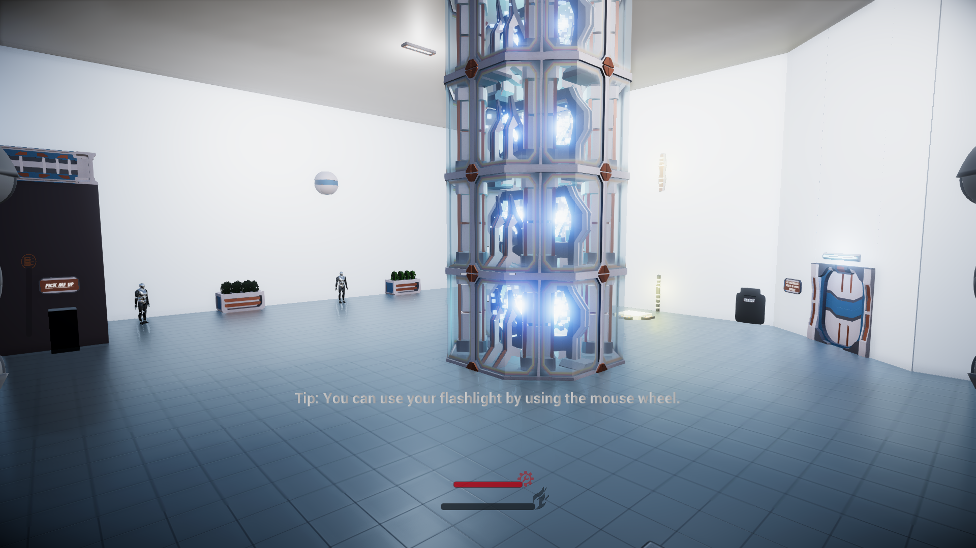

Figure 34: Player HUD

To open doors and progress through the game players must find cubes like the ones seen in figure 35 and match them by colour to their allocated button.

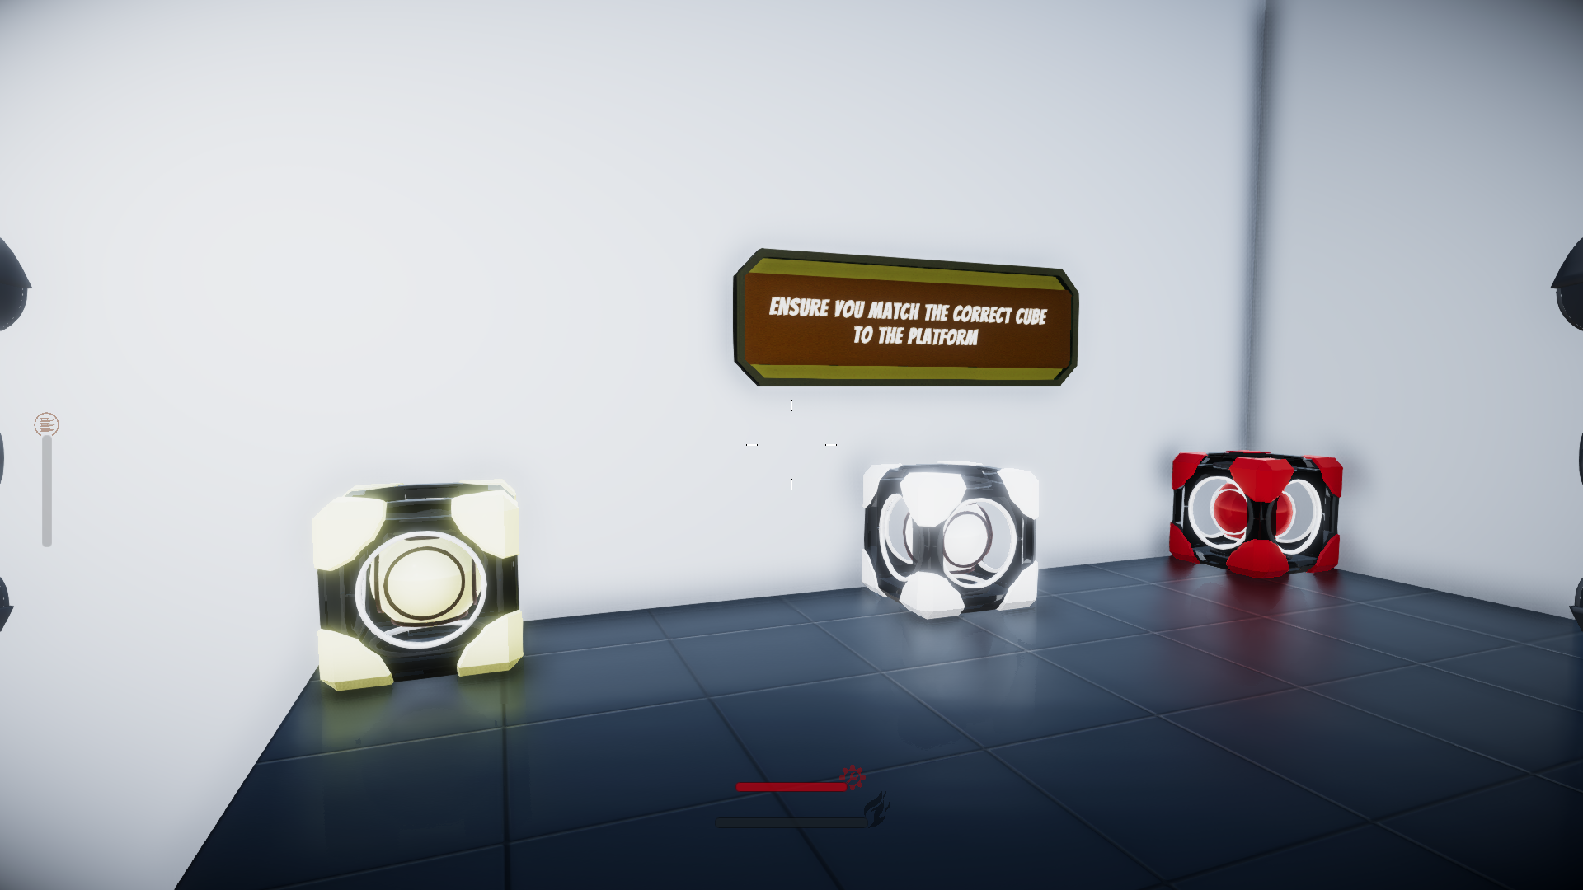

Figure 35: Cubes

While progressing through the game enemies will become much tougher and more challenging as seen in figure 36. To beat them the player is always required to think ahead and use the resources that are around them.

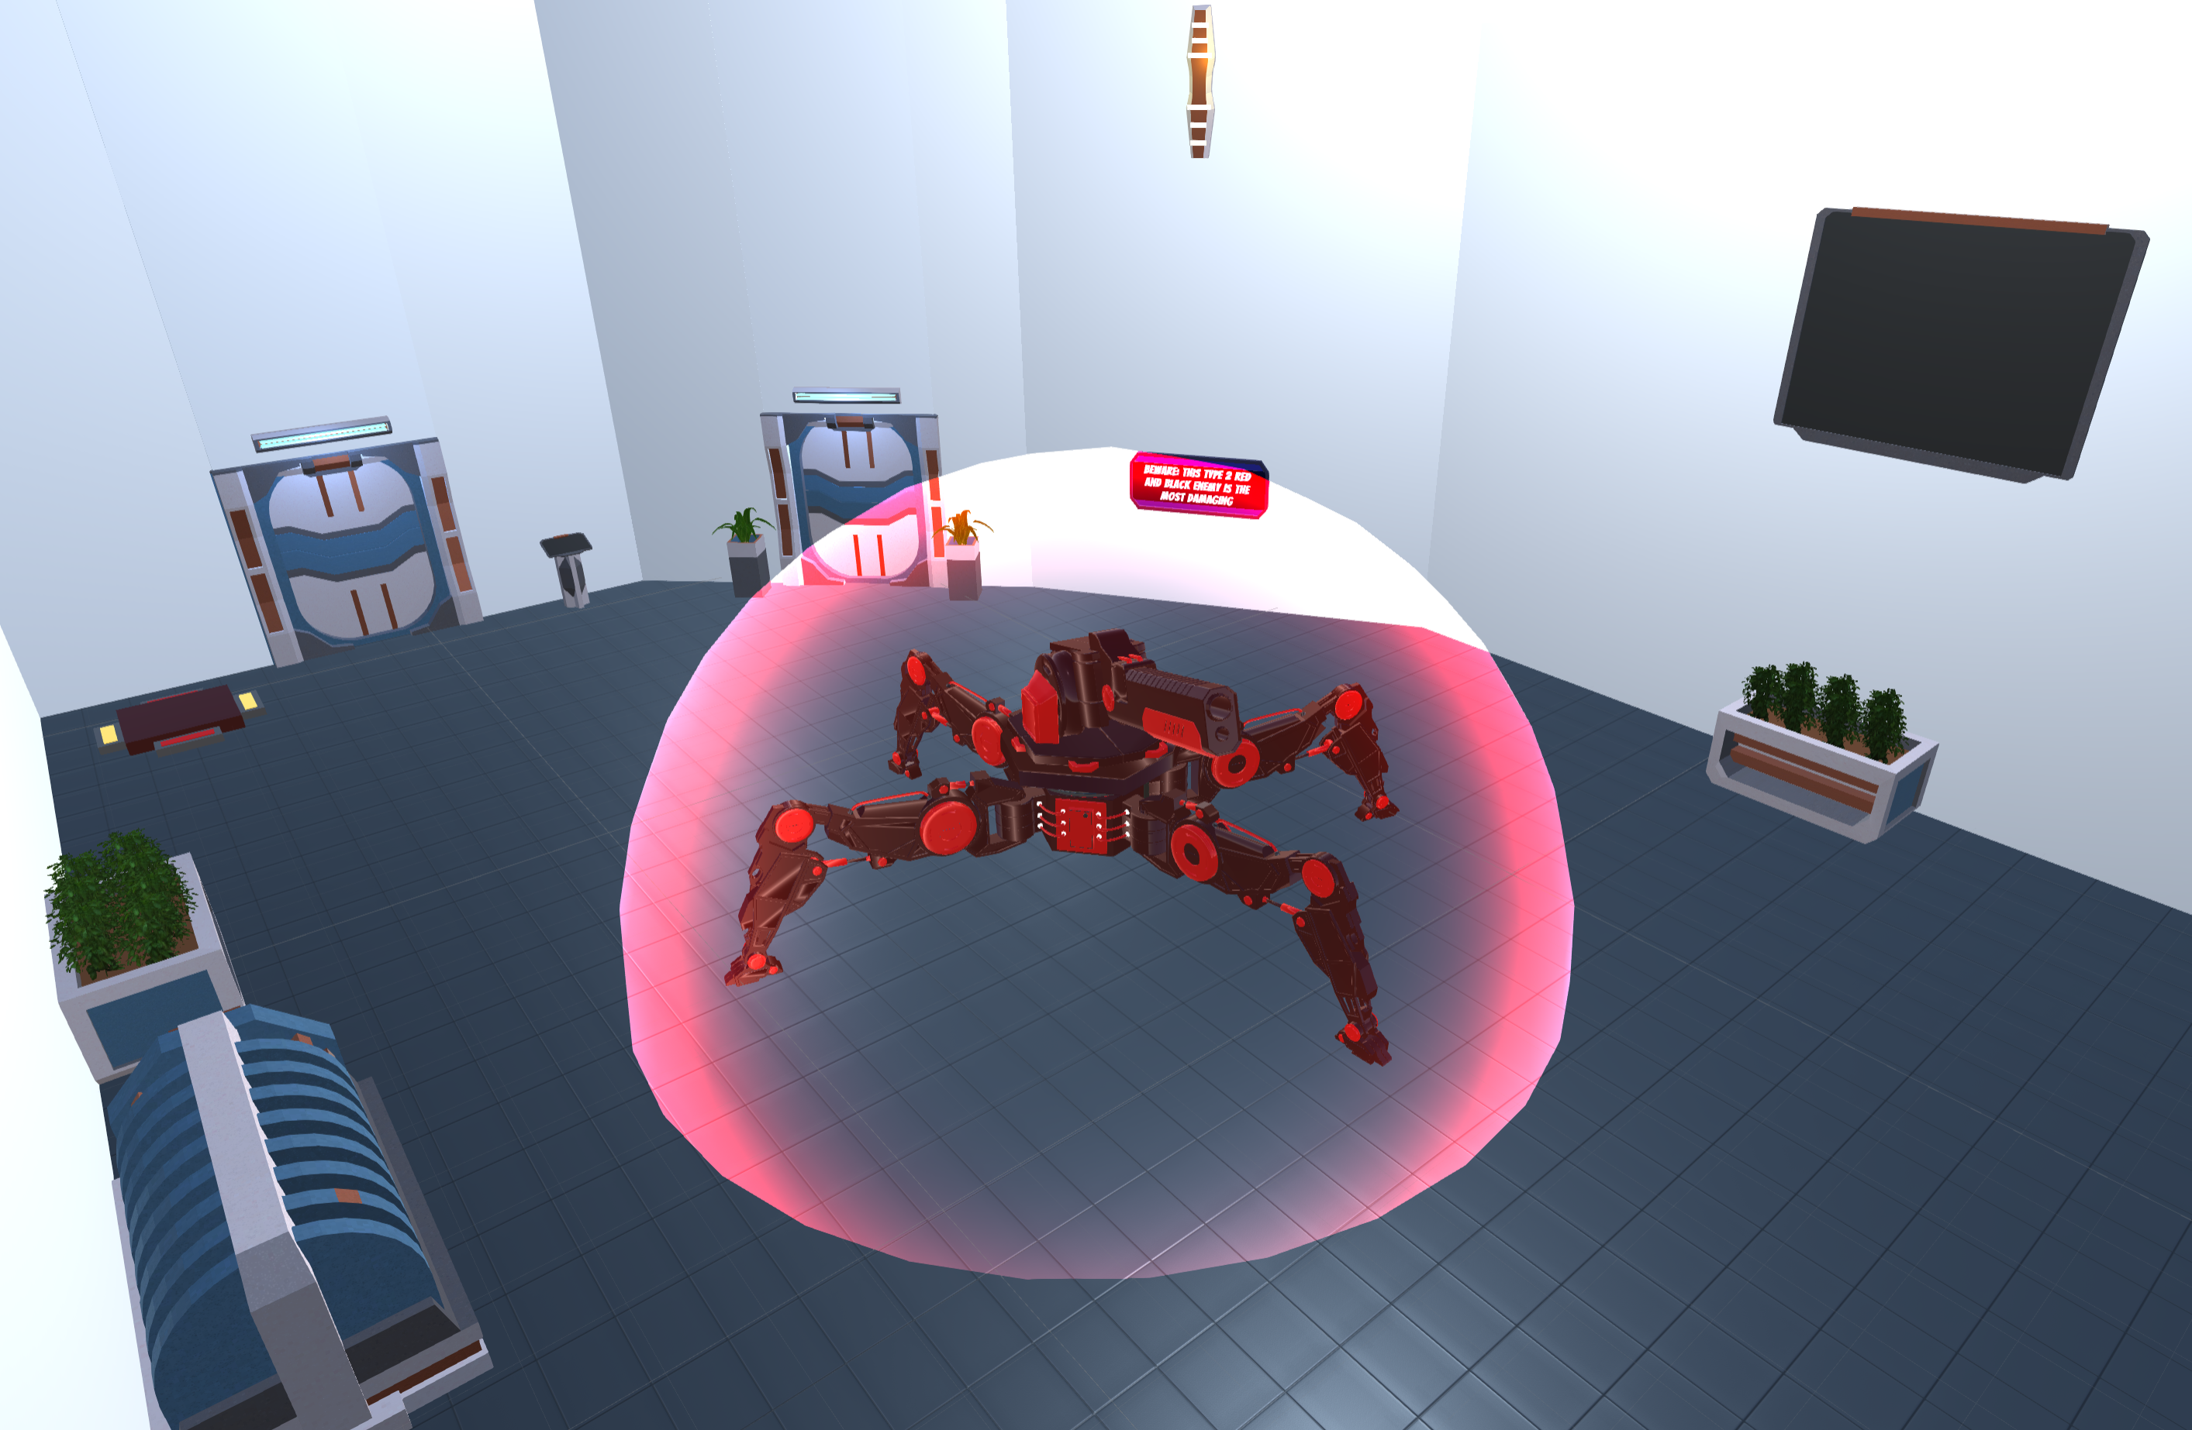

Figure 36: Enemies

The game contains various puzzles that can be found throughout, one example is the fourth level presented in figure 37, where the player must avoid the lights at all cost and retrieve the cube.

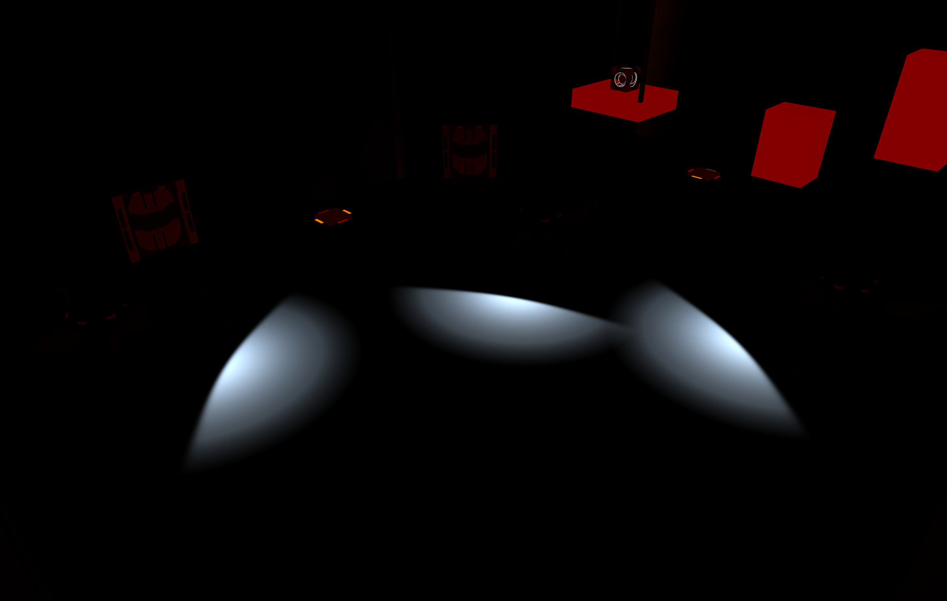

Figure 37: Fourth Level

# Evaluation

## Enjoyment Testing

The enjoyment test as seen in section 4.4.1, was done to test exactly whether the game is enjoyable to play thus excluding it from influencing any of the result in the final control scheme test.

### Test 1

The results of the first test seen in figure 38, determined that although the game was visually pleasing, and the controls were developed to a good standard, some levels were far too difficult, particularly the second and fourth levels where most participants agreed that they did not like these levels due to their difficulty.

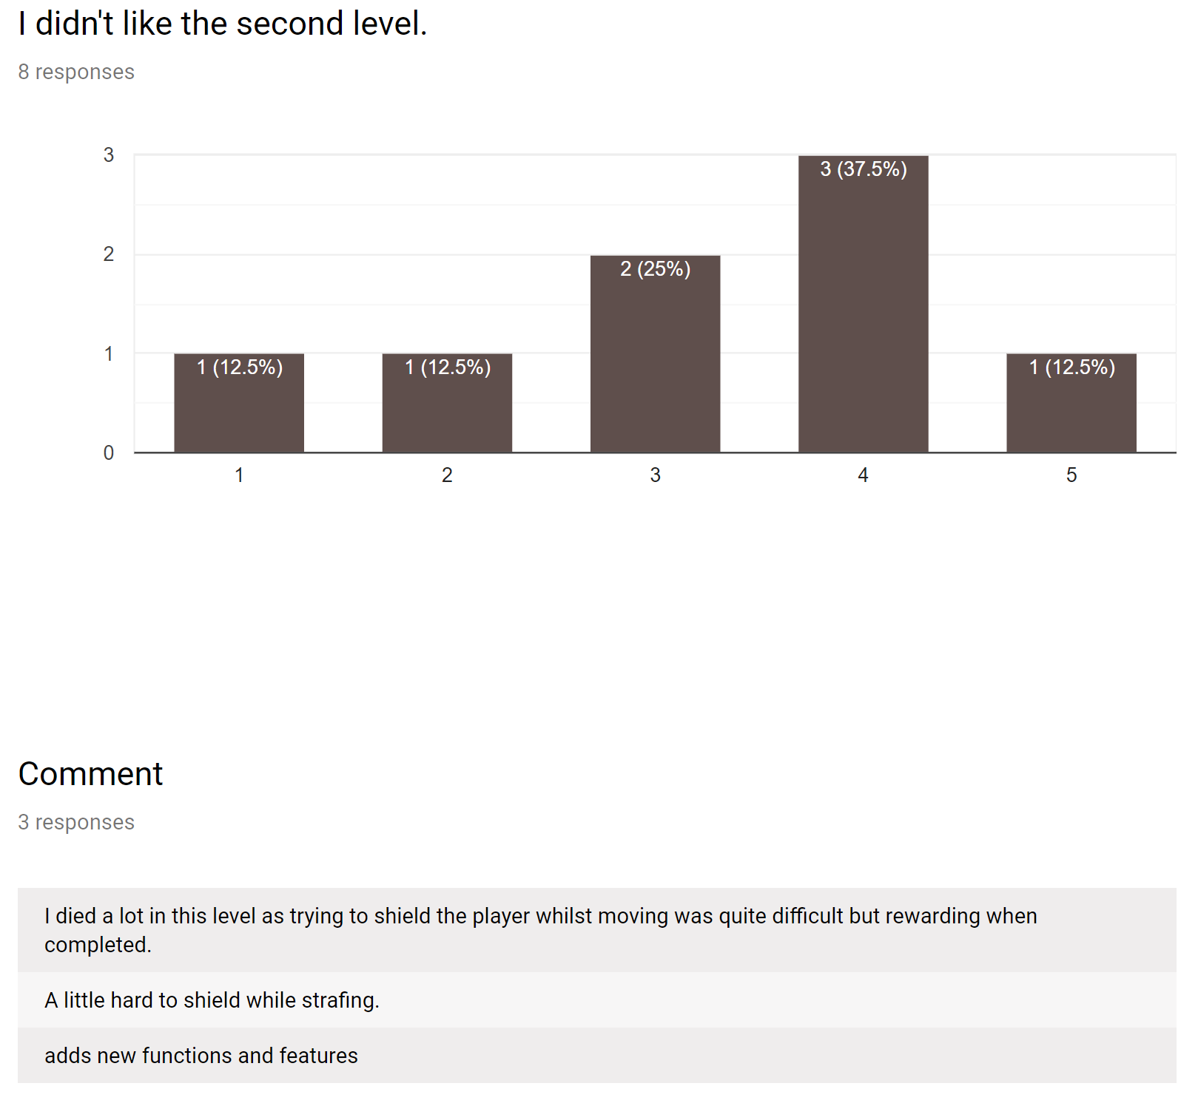



Figure 38: Test 1 - level 2 results

From the results several flaws were identified in the design of levels 2 and 4 and helpful feedback was provided with several ideas on possible improvements for both levels.

As mentioned in section 4.2 - figure 7, if the test does not receive a majority of positive results on each question then the design and implementation stage will reiterate to resolve the problems that were pointed out in the results. During this second pass through the design and implementation stage, all the suggested improvements were made to the level, however one participant did state that the jumping mechanic was not working correctly and that it needs further improvements on it. After careful consideration, improvements to this mechanic were not implemented as the game is played in first-person where jumping exercises are naturally difficult, and the mechanic seemed to be working as intended.

### Test 2

As seen in the appendices item 2, further improvements were made to the second questionnaire by including qualitative questions at the start and separating/merging various questions to improve the quality of the data received.

After testing eight new participants, the results of the second questionnaire, seen in figure 39, were overall very positive throughout:

|  |  |
| --- | --- |
|  |  |
|  | |

Figure 39: Test 2 - Positive Results

From these results, it was determined that the game succeeded in being neither too difficult nor too easy to play, with one participant adding that there is a steady difficulty curve where elements are slowly introduced to the player. Participants also noted in many questions that they enjoyed the games theme, features and puzzles, with many referencing or comparing it to Portal (Valve Corporation, 2007) within their comments.

As the results from this test were positive meaning that the game is satisfying to play with good core mechanics, further improvements are made to the aesthetics of the game to make the game more visually appealing with better graphical content that works perfectly without requiring the change of any functionality.

## Control Scheme Testing

Upon completing the second enjoyment test and receiving positive feedback, the final stage was to test and evaluate the simplification of first-person shooter controls.

### Player Categorisation

To categorise players better in terms of how much experience they have, an average was created between the two experience questions asked within the questionnaire.

2.

1.

|  |  |
| --- | --- |
|  |  |

Figure 40: Experience Calculation

As seen in figure 40, two particants with varying experiences have filled in the questionnaires. Participant one has chosen four on the likert scale when asked how much experience they have in playing games in general, and three in terms of how much experience they have in playing only first person shooters.

To determine which category this participant falls under, both results are added together and the outcome is then divided by two.

If the final result is higher than four, they are placed in group one, if the result is between two and four, they are in the group two and finally, if the result is below two, then they are placed in group three.

The three groups are as follows:

|  |  |
| --- | --- |
| * Group One: | Gamers who play first-person shooters frequently. |
| * Group Two: | People who play games but do not play first-person shooters frequently. |
| * Group Three: | Individuals who play games rarely or do not play at all. |
|  |  |

### Results

The results show that although most of the players from the first group preferred the non-simplified version of the game using the W, A, S, D keys, some agreed that they could also understand how a less experienced player could enjoy the game more using the simplified controls. Various participants from this group also stated that while the simplified controls may be good for a game like the current one being played where few keys are needed, but in a more complex game where many are required, this control scheme would not work. Furthermore, it was noted that in some cases the more experienced participants said that they choose the non-simplified version due to the familiarity of using the typical first-person shooter controls.



Figure 41: Comment by participant 15

For those who were placed in group 2 with an intermediate amount experience in playing games, the results were mixed between preferences. Some preferred the more traditional controls whereas others would prefer the new simplified version with one user stating that they enjoyed the arcade feel to the game where less thinking was involved, allowing players to simply have fun without being on their guard at all times while playing the game.

Additionally, through watching the playthroughs captured using the OBS software, it was clear that players from this group were entertained through simple exploration, reading, and enjoying what features the game has to offer rather than playing with the sole intention of completing the game like most of the participants from the first group.

The results from the third and final group show that most players who are not familiar with playing any computer games enjoyed playing the simplified version more and as seen in figure 42, participant 19 states that they enjoyed using the arrow keys and having the player character automatically shoot when the cursor is over a target. These features were purposefully implemented to remove a level of difficulty that new players may encounter when they first begin playing first-person shooters.



Figure 42: Comment by participant 19

In one case a left-handed person was tested, and they stated that if the I, J, K, L keys were being used rather than the W, A, S, D they would have also chosen the non-simplified version of the game due to having more control over the player character.

After several tests had been completed by the third group, the order in which games were played was reversed to allow inexperienced participants an easier time immersing themselves into the game.

# Conclusion

The aim of this project was to answer the question: What are the effects of simplifying First-Person Shooter controls with a focus on making a first-person shooter game that is more accessible to players of all experiences. Having created two versions of a game with different control schemes, the goal was successfully achieved with many positive results on how players have enjoyed both versions of the game.

Overall, only twenty-one participants completed the control scheme test due to time constraints, and whilst watching them play both versions of the game, it was clear to see that they enjoyed themselves, showing positive emotions by laughing, cheering, showing friends, and discussing it with one another.

However, in some cases players who lacked experience would find themselves becoming very frustrated while playing the non-simplified version due to slow reaction times, having great difficulty using the movement keys correctly, not knowing what each key does, or how to use them correctly and with the aim of this project being to assist new players in by making game controls less complex, it was easy to perceive that these participants were less or no longer frustrated when playing the simplified version of the game.

The results from the final test determined that the simplified controls created for this game were easier and more enjoyable to use for the lesser experienced participants than the higher experienced participants. Players with higher amounts of experience generally opted for the non-simplified version using the W, A, S, D keys largely due the controls being familiar however in most cases they stated that they still enjoyed using the simplified controls but if the game were more complex, using these controls would be impossible. In contrast, participants with less amount of experience enjoyed the simplified controls more due to the use of the arrow keys and the auto shoot mechanic making the game much easier and more accessible to players with any amount of experience.

One of the most noted upon issues with the simplified controls was the use of the ctrl key to jump and with the game requiring a lot jumping and gliding, players stated that their little finger began to ache quickly due to the prolonged usage. However, after watching players who wanted to continue playing after the ten-minute mark, it was noted that they became progressively relaxed the further they advanced in the game with some players completely forgetting about the ache. Additionally, as the players progressed in the simplified version it was noted that those with little to no experience had a change in behaviour where they became more confident and sometimes destructive with their character.

One of the biggest issues that could have possibly affected the project was the difficulty of the game. The artefact was purposefully made to be very difficult in order to completely assess how quickly player’s skills develop over time, how fast they progress through the game, how big the learning curve is, and whether or not the control scheme assists the player in overcoming a difficult task. This could have affected the project as some players did find that the jumping puzzles were pushing them to their limit making them become quite frustrated and as a result they may have answered the questionnaire negatively rather than honestly.

Another, slightly smaller issue, was one that occurred during the final test when assessing inexperienced participants. The order in which games were played was reversed for a short while meaning that some of the participants were able to grasp game mechanic easier than others that were in the same group.

# Critical Reflection

In this critical reflection the Gibbs reflective cycle will be used to best structure the reflective analysis. Gibbs (1988) suggests using 6 stages of reflection and is presented in figure 43.

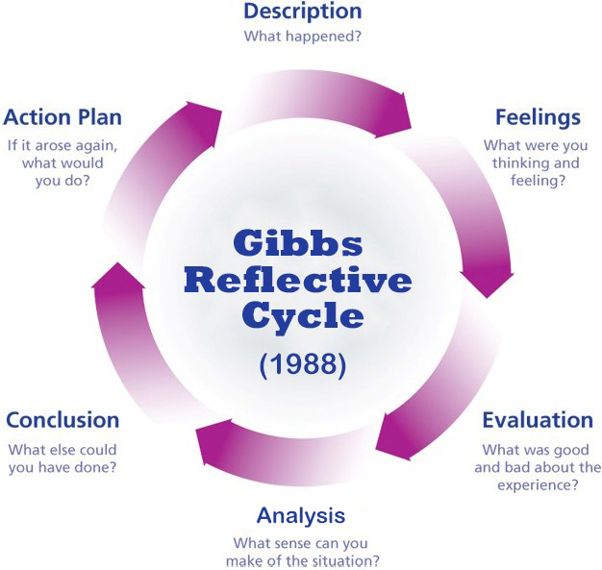

Figure 43: Gibbs Reflective Cycle

## Description

This project consisted of creating a control scheme that allows new players an easier way immersing themselves within first-person shooters while controls that are simple to use and understand. This was done by implementing two identical games with differing control schemes.

The project itself was successful with one small error when collecting data where all participants should have used the same order in which they play the games no matter the circumstances.

## Feelings

I personally feel extremely proud of both the artefact and this document, but I do feel slightly saddened that it was intentionally developed to be very difficult as it would have been more satisfying to have created a game that didn’t test a player’s skill limit upon every corner, however if this was the case the data received would have been very limited.

Furthermore, even though the game is difficult, I’m very happy with all the positive feedback received from participants and it makes me even prouder to know that players still thoroughly enjoyed playing it no matter how much experience they had.

I’m also very pleased with the amount of work that I did to learn new techniques, create models, shaders, scripts, animations and audio blending. The creation of shaders was one best parts of the project, and they can be re-used in any other game.

I also feel overjoyed to see that this project was a success in terms of simplifying controls for new players who were happier to play the game and attempt to compete with friends who had more experience.

## Evaluation

Overall, I think that this game will make an incredible addition to my portfolio as with having so many people who have played it, each giving really good feedback, which in turn gave me a lot of confidence and motivation to complete the project to the best to my ability.

It was however very disappointing to have made the mistake of changing game order for some of those who were inexperienced as this could resulted in some of the data being skewed. However, this may not be a major issue as after all both games were played.

## Analysis

A lot of useful research was done prior to and after the development of the game and one of the lessons learnt from this experience is that designing jumping puzzles suitable for first-person shooters is a very difficult feat to accomplish.

During the design process, it was interesting to see that sketches and experience flow diagrams really helped in the design of the game and it is an aspect that I would like to use in future projects as they greatly improved the quality of production.

The one-page design document found in section 5.1.4, also significantly assisted when testing participants, as when they were handed it, just as Librande specified, they were able to quickly understand and identify different types of enemies and efficiently dispatch or avoid them when necessary (Librande, 2010).

The Gantt chart, whilst it was a fantastic document that at first allowing me to put all my plans into perspective, it was however mostly used during the first stages of artefact development rather than the whole way through, as I found myself working less toward the what was on the chart and more toward my own initiative. This was most likely due to timeframes being missed or the addition of elements that did not exist on the chart.

## Conclusion

Unfortunately, several ideas and features were left incomplete or not implemented due to time constraints. The first was an in-game data collection and questionnaire system that automatically saves all its data for the current participant to an external file that can be easily imported into Microsoft Excel. This was abandoned after both the simplified and non-simplified versions of the game were combined into one game with different control settings.

During the development of the game, I regret not adding any incentives to complete levels. Winning rewards or new abilities would have significantly added to player experience and gameplay, however it needed to have been implemented in a way that didn’t affect the difficulty of the game as this was a crucial part in the success of player testing. If this had been implemented correctly, it may have alleviated the issue of difficulty mentioned in section 7 as most players would have been rewarded for their hard work giving them a more positive outlook toward the game.

Another part of the game that was left incomplete was the robot animations. Robots within the game were left stationary with only top half of their body being able move. It was decided early on that it would require more time to successfully animate all robots. However, on a positive note, this would have made the already difficult game, even harder.

The final feature that was left incomplete was the flight mechanic which was a function that was partially removed earlier in development due to being broken. During the first enjoyment test, players seemed to really enjoy the freedom that it gave as well as being a unique mechanic and it a feature that I do really regret removing.

## Action plan

If I were to do this project again there are numerous things that I would do differently. One in particular, is to allocate more time to testing participants as this stage in the process took much longer than expected, especially when attempting to find people who meet the requirements to participate in the testing process.

This leads onto another point of the project that I would like to have done differently, the way participants were found. If this could have been done differently, I would have distributed posters across the university with my email attached for people to email me. Once a participant was found we would then be able to find a quiet room, as most of the labs in the university were always either busy or occupied.

In addition, a link could have been posted on social media to invite external participants to play the game and complete questionnaires.

During this testing process I would also like to use validated questionnaires as it was extremely difficult creating my own questionnaire, while attempting to make it as clear a possible to gather the exactly correct information

# Appendices

## Item 1: Enjoyment Questionnaire v1

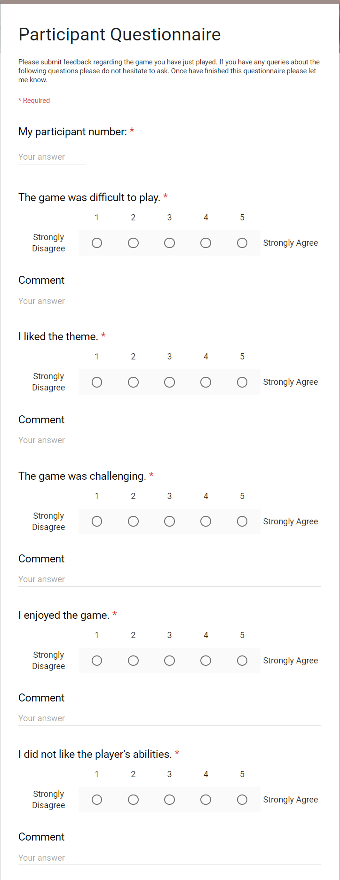

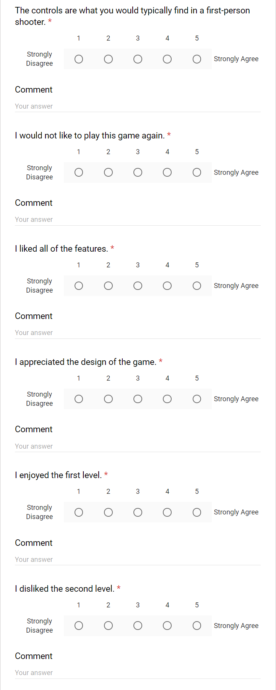

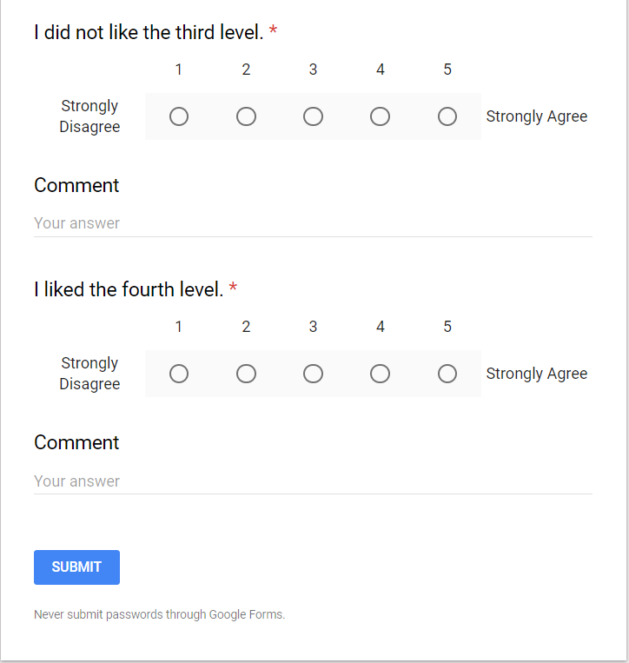

## Item 2: Enjoyment Questionnaire v2

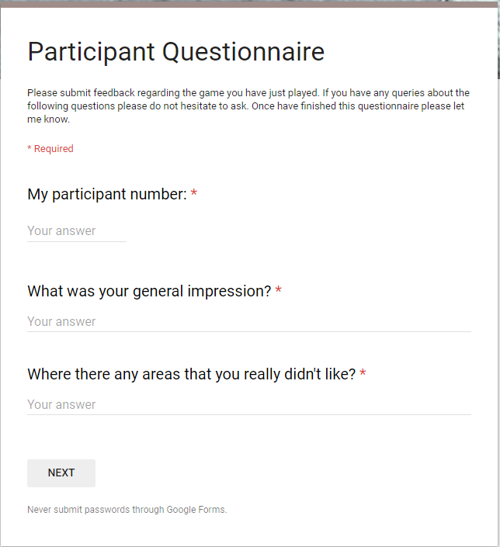

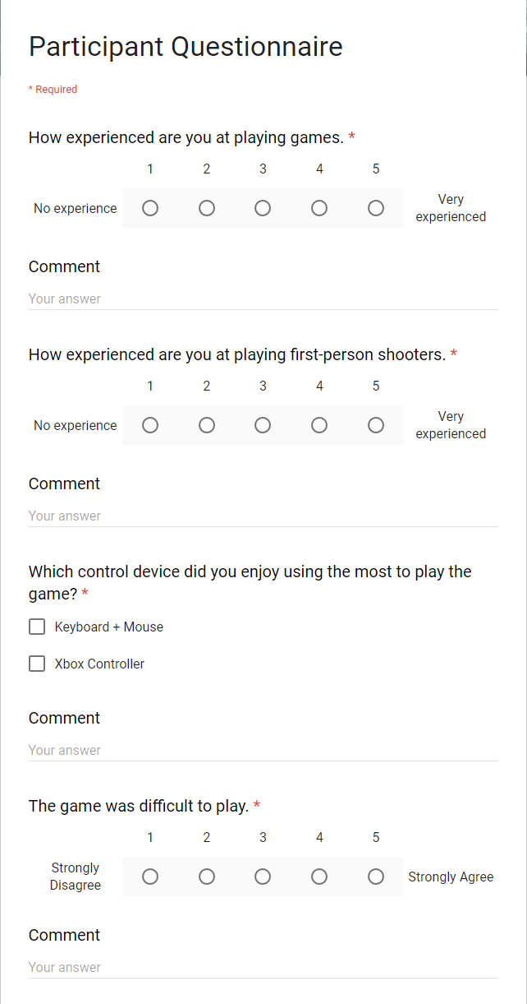

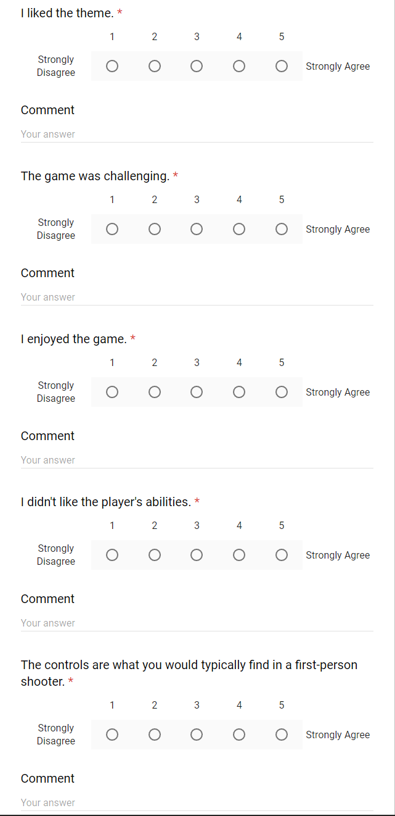

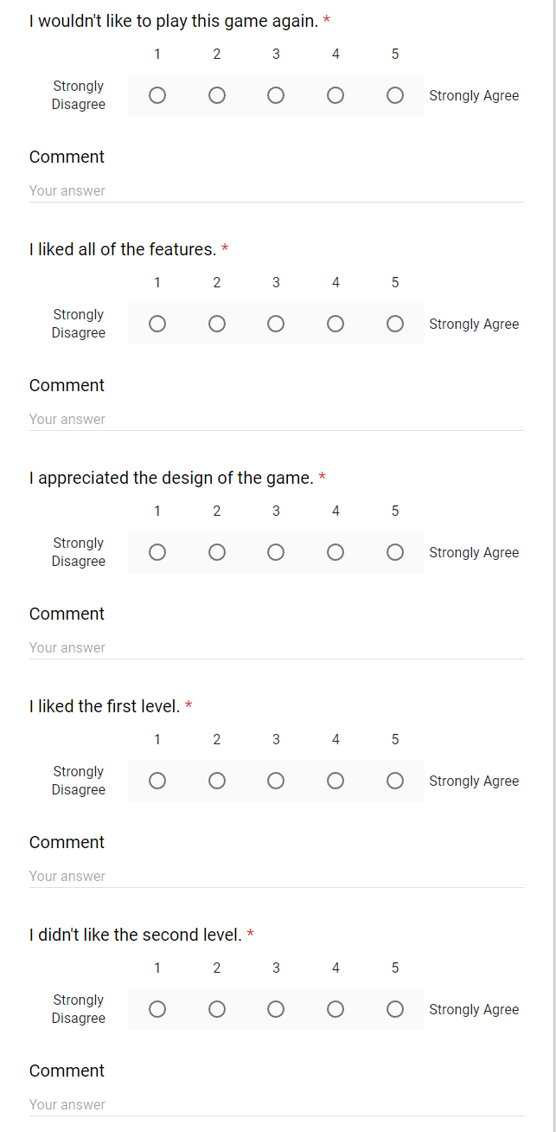

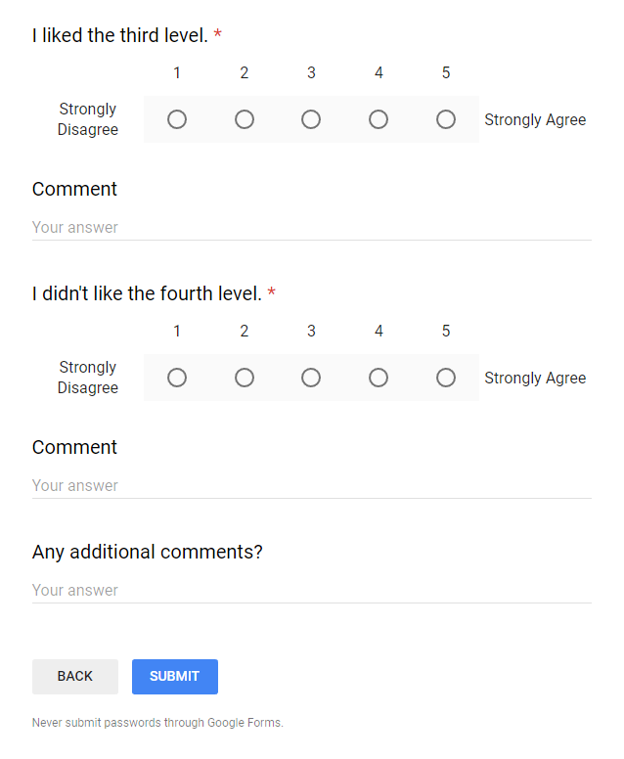

## Item 3: Control Questionnaire

*Section 2*

*Section 1*

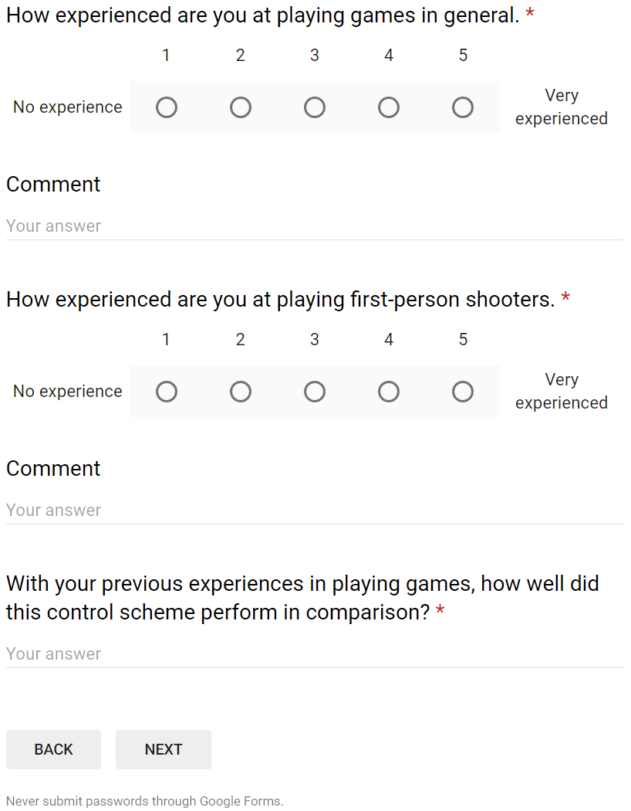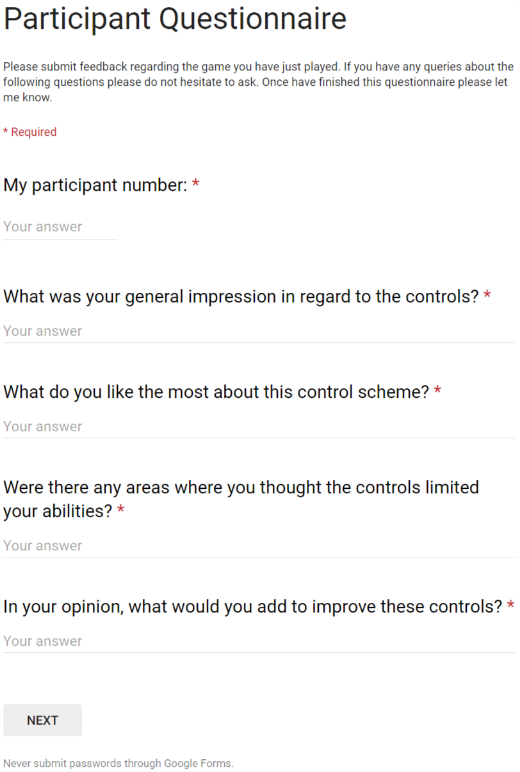

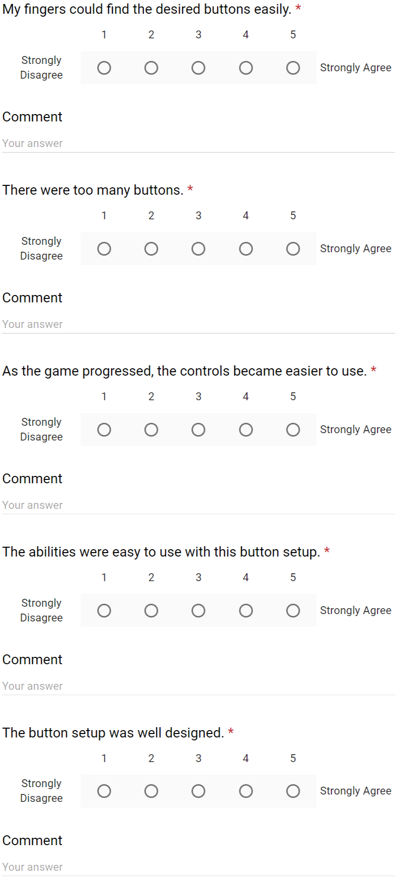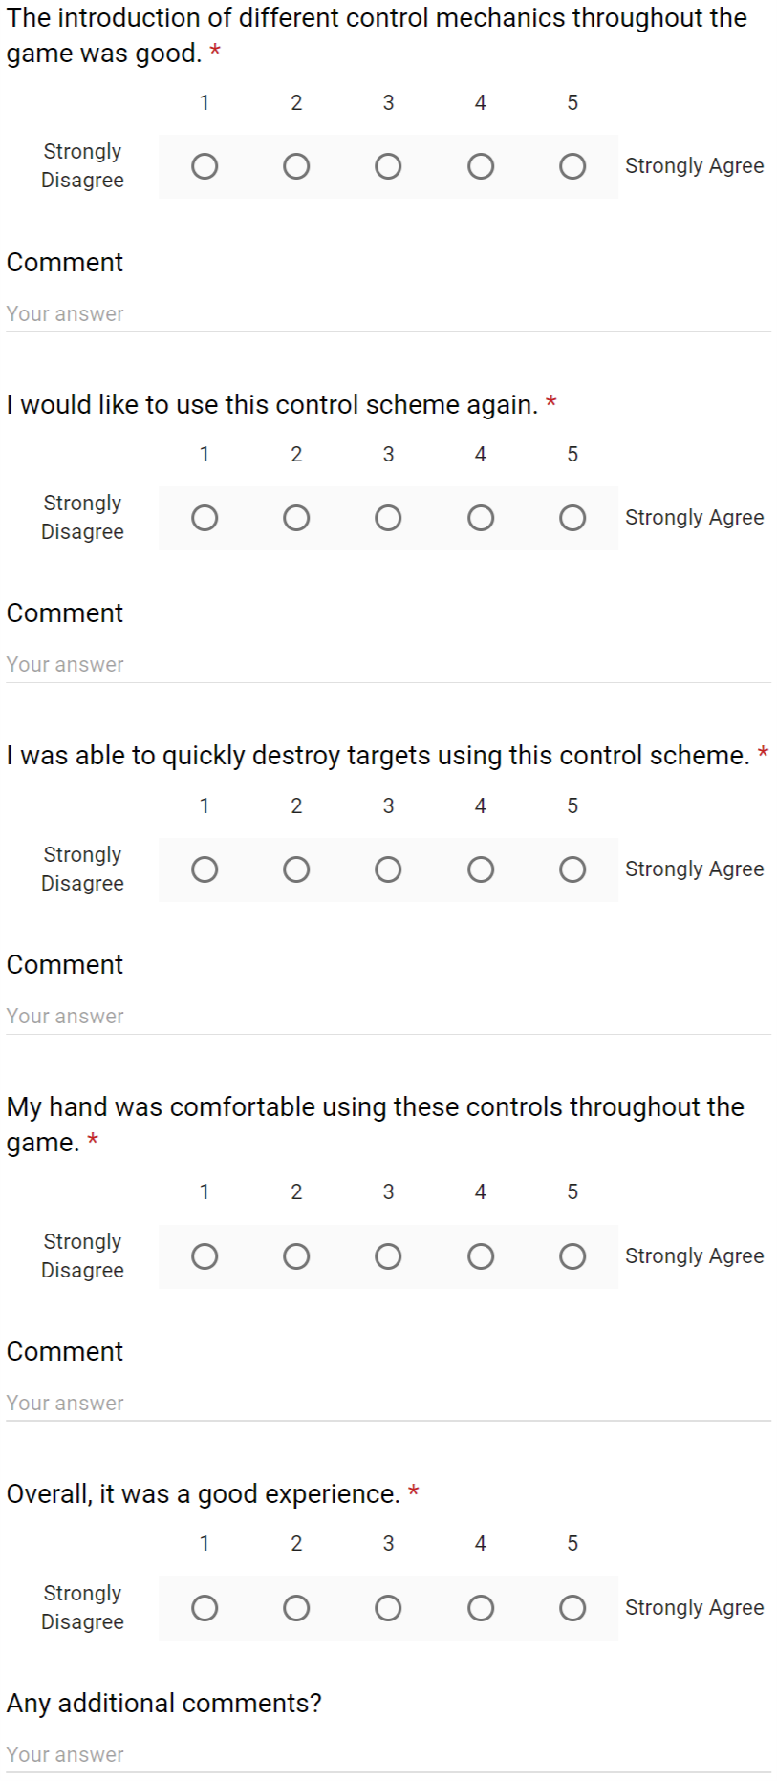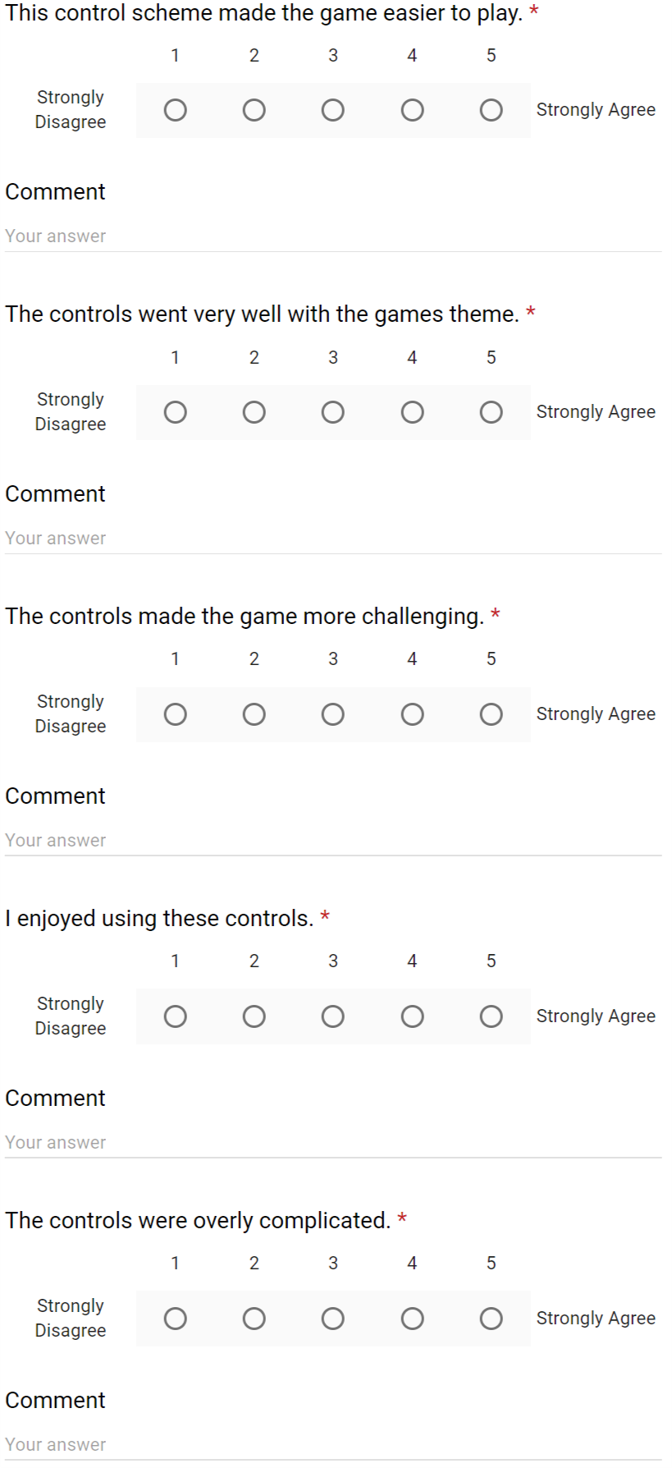

*Section 3*

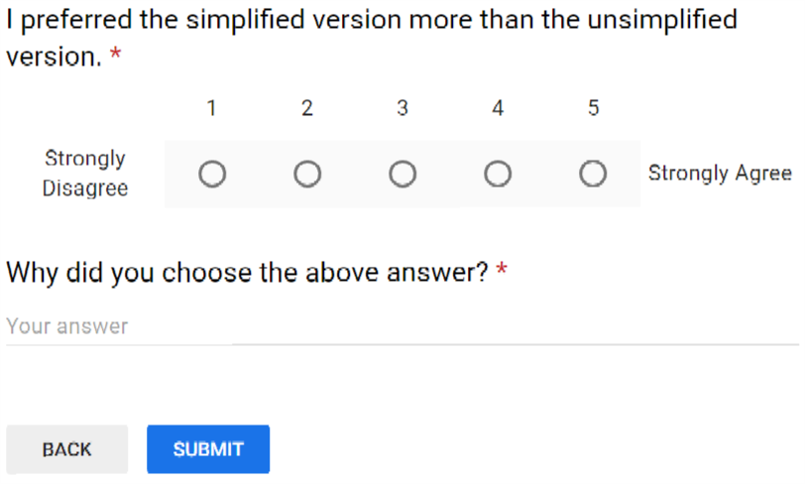

*Section 4*

## Item 4: One-Page Design Document



# References

Anderson, C.A., Gentile, D.A. and Buckley, K.E., 2007. Violent video game effects on children and adolescents: Theory, research, and public policy. Oxford University Press.

Atkins, B., 2003. More than a game: The computer game as fictional form. Manchester University Press.

Babich, N., 2017. Prototyping 101: The Difference between Low-Fidelity and High-Fidelity Prototypes and When to Use Each.

Bamberger, M., 2012. Introduction to mixed methods in impact evaluation. Impact Evaluation Notes, 3(3), pp.1-38.

Beck, K. and Gamma, E., 2000. Extreme programming explained: embrace change. addison-wesley professional.

Bhat, K., 2016. Call of Duty has surpassed over $15 billion in sales since 2003 launch. [online] Charlie Intel. Available at: <https://charlieintel.com/2016/02/11/call-of-duty-has-surpassed-over-15-billion-in-sales-since-2003-launch-bo3-season-pass-sales-rate-highest-in-franchise-history/> [Accessed 15 October 2018].

Boehm, B., 1986. A spiral model of software development and enhancement. ACM SIGSOFT Software engineering notes, 11(4), pp.14-24.

Busche, L., 2014. The Skeptic’s Guide to Low-Fidelity Prototyping. Smashing magazine.

Calleja, G., 2011. In-game: From immersion to incorporation. MIT Press.

Cheng, K., Cairns, P., 2005. Behaviour, realism and immersion in games. In CHI'05 extended abstracts on Human factors in computing systems (pp. 1272-1275). ACM.

Costikyan, G., 1994. I have no words and I must design. Interactive Fantasy# 2. British roleplaying journal.

Craighead, J., Burke, J. and Murphy, R., 2008, September. Using the unity game engine to develop sarge: a case study. In Proceedings of the 2008 Simulation Workshop at the International Conference on Intelligent Robots and Systems (IROS 2008).

Crawford, C., 1984. The art of computer game design.

Cummings, A.H., 2007. The evolution of game controllers and control schemes and their effect on their games. In The 17th annual University of Southampton multimedia systems conference (Vol. 21).

DeCoster, R., 2018. PAX South 2018 -- Balance in Game Design. [video] Available at: <https://www.youtube.com/watch?v=NXD8YQ7j_Qk> [Accessed 20 January 2019]

Denisova, A., Cairns, P., 2015. First person vs. third person perspective in digital games: Do player preferences affect immersion? In Proceedings of the 33rd Annual ACM Conference on Human Factors in Computing Systems (pp. 145-148). ACM.

Ermi, L., Mäyrä, F., 2005. Changing Views: Worlds in Play. International Conference. [online] Digra. Available at: <http://www.digra.org/digitallibrary/publications/fundamental-components-of-the-gameplay-experienceanalysing-immersion/> [Accessed 26 December 2018].

Gibbs, G., 1988. Gibbs’ reflective cycle. [online] University of Edinburgh. Available at: <https://www.ed.ac.uk/reflection/reflectors-toolkit/reflecting-on-experience/gibbs-reflective-cycle> [Accessed 01 April 2019].

Godoy, A., Barbosa, E.F., 2010. Game-Scrum: An approach to agile game development. Proceedings of SBGames, pp.292-295.

Gkikas, K., Nathanael, D. and Marmaras, N., 2007, May. The evolution of FPS games controllers: how use progressively shaped their present design. In Panhellenic Conference on Informatics (PCI).

Grimshaw, M., 2008. Sound and immersion in the first-person shooter. International Journal of Intelligent Games and Simulation, 5(1), pp.119-124.

Haas, J.K., 2014. A history of the Unity game engine.

Hornshaw, P., 2018. The History of Battle Royale: From Mod to Worldwide Phenomenon. [online] Digital Trends. Available at: <https://www.digitaltrends.com/gaming/history-of-battle-royale-games/> [Accessed 18 October 2018]

House, M., 2015. Implementing Extreme Programming (XP). [online] Agile Development. Available at: <https://www.agiledevelopment.org/agile-talk/120-implementing-extreme-programming> [Accessed 21 January 2019].

Hunicke, R., LeBlanc, M. and Zubek, R., 2004, July. MDA: A formal approach to game design and game research. In Proceedings of the AAAI Workshop on Challenges in Game AI (Vol. 4, No. 1, p. 1722).

Jaffe, A., Miller, A., Andersen, E., Liu, Y.E., Karlin, A. and Popovic, Z., 2012, October. Evaluating Competitive Game Balance with Restricted Play. In AIIDE.

Jakubauskas, T., 2015. Staying ahead with DirectX 12. [online] Unity 3D Blogs. Available at: <https://blogs.unity3d.com/2015/01/22/staying-ahead-with-directx-12/> [Accessed 21 January 2019]

Jansz, J. and Tanis, M., 2007. Appeal of playing online first-person shooter games. Cyberpsychology & behaviour, 10(1), pp.133-136.

Jones, J.C., 1992. Design methods. John Wiley & Sons.

Juul, J., 2011. Half-real: Video games between real rules and fictional worlds. MIT press.

Kica, A., La Manna, A., O'Donnell, L., Paolillo, T. and Claypool, M., 2016, October. Nerfs, buffs and bugs-analysis of the impact of patching on League of Legends. In Collaboration Technologies and Systems (CTS), 2016 International Conference on (pp. 128-135). IEEE.

Klochek, C. and MacKenzie, I.S., 2006, June. Performance measures of game controllers in a three-dimensional environment. In Proceedings of Graphics Interface 2006 (pp. 73-79). Canadian Information Processing Society.

Larman, C., Basili, V.R., 2003. Iterative and incremental developments. a brief history. Computer, 36(6), pp.47-56.

Larman, C., 2004. Agile and iterative development: a manager's guide. Addison-Wesley Professional.

LeBlanc, M., 2004. Mechanics, Dynamics, Aesthetics: A Formal Approach to Game Design [lecture]. Northwestern University, April 2004. Available at: [http://algorithmancy.  
8kindsoffun.com/MDAnwu.ppt](http://algorithmancy.8kindsoffun.com/MDAnwu.ppt) [Accessed 07 February 2019]

Librande, S., 2010. One-Page Designs. [video] Available at: [https://www.gdcvault.com  
/play/1012356/One-Page](https://www.gdcvault.com/play/1012356/One-Page) [Accessed 05 February 2019]

Likert, R., 1932. A technique for the measurement of attitudes. Archives of psychology.

Looser, J., Cockburn, A. and Savage, J., 2005. On the validity of using First-Person Shooters for Fitts' law studies. People and Computers XIX, 2, pp.33-36.

Marco, 2017. Spiral Model for Game Development: Techniques To Develop Games. [online] Game Developer Tips. Available at: <http://gamedevelopertips.com/spiral-model-for-game-development/> [Accessed 21 January 2019]

Mackenzie, I.S., 1992. Fitts' law as a performance model in human-computer interaction.

Maylor, H., 2001. Beyond the Gantt chart: Project management moving on. European Management Journal, 19(1), pp.92-100.

Millard, A., 2018. Why Are Games So Hard To Balance? [video] Available at: <https://www.youtube.com/watch?v=K3n-Sy2Ko4I> [Accessed 20 January 2019]

Osorio, D., 2016. How to design your One Page. [online] Gamasutra. Available at: <https://www.gamasutra.com/blogs/DavidOsorio/20161220/287965/How_to_design_your_One_Page.php> [Accessed 05 February 2019]

OverwatchWiki, 2016. Passive Ability. [online] Gamepedia. Available at: [https://overwatch.  
gamepedia.com/Passive\_ability](https://overwatch.gamepedia.com/Passive_ability) [Accessed 07 February 2019]

Poels, K., De Kort, Y. and Ijsselsteijn, W., 2007. It is always a lot of fun!: exploring dimensions of digital game experience using focus group methodology. In Proceedings of the 2007 conference on Future Play (pp. 83-89). ACM.

Poole, S., 2011. Trigger happy. Simon and Schuster.

Qin, H., Patrick Rau, P.L. and Salvendy, G., 2009. Measuring player immersion in the computer game narrative. Intl. Journal of Human–Computer Interaction, 25(2), pp.107-133.

Quora, 2018. What is the best platform to play First Person Shooters (FPS): PC or consoles? [online] Quora. Available at: <https://www.quora.com/What-is-the-best-platform-to-play-First-Person-Shooters-FPS-PC-or-consoles> [Accessed 26 Decemeber 2018].

Reddit, 2018. What really is immersion in video games? [online] Reddit. Available at: <https://www.reddit.com/r/gaming/comments/a00b9z/what_really_is_immersion_in_video_games/> [Accessed 26 Decemeber 2018].

Reisinger, D., 2011. Call of Duty: Modern Warfare 3 makes $1 billion--in 16 days. [online] CNET. Available at: <https://www.cnet.com/news/call-of-duty-modern-warfare-3-makes-1-billion-in-16-days/> [accessed 10 October 2018]

ROUSE III, R.I.C.H.A.R.D., 2014. Game design. In the Routledge Companion to Video Game Studies (pp. 109-116). Routledge.

Salen, K., Tekinbaş, K.S. and Zimmerman, E., 2004. Rules of play: Game design fundamentals. MIT press.

Schwaber, K., 1997. Scrum development process. In Business object design and implementation (pp. 117-134). Springer, London.

Schwaber, K., Beedle, M., 2002. Agile software development with Scrum (Vol. 1). Upper Saddle River: Prentice Hall.

Sweetser, P. and Wyeth, P., 2005. GameFlow: a model for evaluating player enjoyment in games. Computers in Entertainment (CIE), 3(3), pp.3-3.

Sylvester, T., 2013. Designing games: A guide to engineering experiences. "O'Reilly Media, Inc.".

University of Newcastle, 2019. Research Methods: What are research methods? [online] Library Guides. Available at: <https://libguides.newcastle.edu.au/researchmethods> [Accessed 31 January 2019]

Vicencio-Moreira, R., Mandryk, R.L., Gutwin, C. and Bateman, S. 2014., The effectiveness (or lack thereof) of aim-assist techniques in first-person shooter games. In Proceedings of the 32nd annual ACM conference on Human factors in computing systems (pp. 937-946). ACM.

Wilde, T., 2016. How WASD became the standard PC control scheme. [online] PC Gamer. Available at: <https://www.pcgamer.com/uk/how-wasd-became-the-standard-pc-control-scheme/> [Accessed 15 January 2019]

Wisdom, J. and Creswell, J.W., 2013. Mixed methods: integrating quantitative and qualitative data collection and analysis while studying patient-centered medical home models. Rockville: Agency for Healthcare Research and Quality.

WowWiki, 2004. Passive Ability. [online] World of Warcraft Wiki. Available at: <https://wowwiki.fandom.com/wiki/Passive_ability> [Accessed 07 February 2019]

Zimmerman, E., 2003. Play as research: The iterative design process. Design research: Methods and perspectives, 2003, pp.176-184.